Connie (Babin) Chapman
July 29, 1955 – March 9, 2025

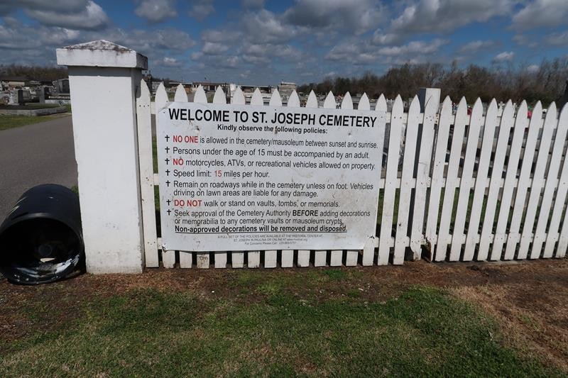

Connie Babin Chapman, a loving mother, grandmother, and sister passed away on March 9, 2025, at the age of 69.
A native and resident of Paulina, LA, Connie was born on July 29, 1955 to Louis JC Babin and Lucille Martin. She retired from Walmart in Gonzales, LA after over 30 years of service.
Survivors include her daughter Karen Bridge, son in law Michael Bridge, and grandchildren Lauren and Alexander Bridge. She is also survived by her siblings Edward Babin, Gail B. (Darryl) St. Pierre, Chris Babin, Joan B. (Kerry) Lambert, and Louis (Jacquie) Babin Jr. As well as numerous nieces and nephews who she loved dearly.
Preceded in death by parents, brother Keith Babin and sister in law Jane Deroche Babin.
Visitation will be held on Tuesday, March 18, 2025 10:00am - 11:00am at St Joseph Catholic Church in Paulina, LA followed by Mass of Christian Burial at 11:00am. Burial will follow at St Joseph Mausoleum.
Rose Lynn Funeral Home, Lutcher, LA
March 20, 2025

