George Fredrick Coneglio Jr.
Abt. 1931 – November 13, 2024

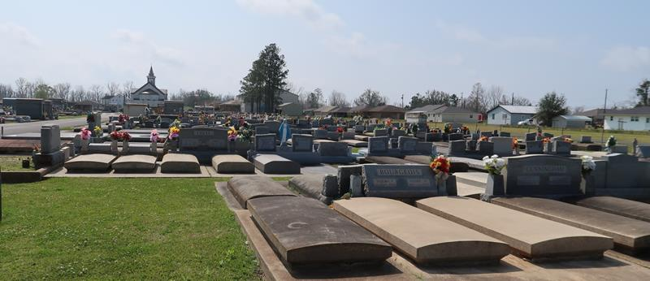

George Fredrick Coneglio, Jr. passed away on Wednesday, November 13, 2024 at the age of 93. He was born in Gramercy and a resident of Lutcher, LA.
Beloved husband of the late Faith Scharwath Coneglio. Loving father of Stephanie C. Moore (David), Lauren C. Nosacka (Thomas), Karl E. Coneglio (Steffani), Maurie C. Duhe (Scott) and the late George H. Coneglio, III (the late Tammy) and the late David S. Coneglio (Gigi). Grandfather of Apryl B. Clavelle (Jarrod), Angelle B. Buschbaum (Dennis, Jr.), Lyle P. Brady (Shannon), Aaron P. Coneglio, Summer C. Ramsey (Jacob), Nina D. Dildy (Mike), the late Brandon Nosacka (Sherrie), Jessica VanSickle (Stephen), Seth Nosacka (Lezlie), Emily Nosacka, Joshua Coneglio (Madeline), Katie C. Matherne (Wesley), Karl Coneglio, Jr., Beth Coneglio, Chandler Duhe, Dylan Duhe, Jordan Duhe, Brendon Duhe and Bryce Duhe. Great grandfather of Eve L. Rodriguez, Alex Clavelle, Adam Clavelle, Dennis Buschbaum, III, Brianne Buschbaum, Mia Buschbaum, Avery Shaffer, Reese Ramsey, Anna Dildy, Caroline Dildy, James Dildy, Carter Nosacka, Jonah Prestridge, Elliana VanSickle, Griffin VanSickle, Brooks Nosacka, Noah Honeycutt, Elliott Nosacka and Wells Coneglio. The Great-Great Grandfather of Jenna Bushbaum, Ryan Buschbaum, Collyn Clavelle, Nolan Clavelle and Bently Lair. Son of the late George (Joe) Coniglio, Sr. and Lena C. Coniglio. Brother of the late Rosie, Annie, Rita, Josie, Phillip, Sam, Johnny, Benney, Paul, George and Mary.
Relatives and friends are invited to attend the Visitation and Funeral Mass at St. Joseph Catholic Church, 2130 Rectory St., Paulina on Wednesday, November 20, 2024. Visitation will be held at the church from 10:00 a.m. to 12:00 p.m. followed by a Funeral Mass at 12:00 p.m. Inurnment will be held at a later date in St. Joseph Cemetery, Paulina, LA.

Rose Lynn Funeral Home, Lutcher, Louisiana
November 17, 2024

