Lynn Rogers Detillier Sr.
October 17, 1935 – March 18, 2002

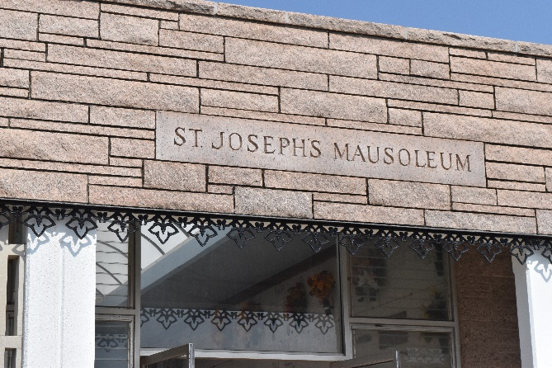

Lynn Rogers Detillier, On Monday March 18, 2002 At 8:00 P.M. In Laplace. Age 66. A Native Of Lutcher And A Resident Of Gramercy. Husband Of The Late Mary Catherine 'T-Cat' Deroche Detillier. Son Of The Late Alcee And Marguerite Arabie Detillier. Father And Father-In-Law Of Cindy And Keith Martin-Paulina, La., Hilda And Andrew Montero- Paincourtville, Lynn Detillier Jr., Andy And Deidre Detillier, David Detillier, And Jason And Rachel Detillier All Of Gramercy. Brother Of Shirley Borrello, Indianapolis, Ind., Elsie Levet, Lutcher, Thelma Dejean, Des Allemands, Jeannette Detillier, Lutcher, Percy Detillier, Lutcher, Dudley Detillier, Gramercy, Archie Detillier, Norco. Preceeded In Death By Charles (Inky) Detillier. Also Survived By 13 Grandchildren. Mass Of Christian Burial At 11:00 Am On Thursday At Sacred Heart C.C. In Gramercy. Interment In St. Joseph Mausoleum. Visitation At H. C. Alexander Funeral Home In Lutcher From 6 Pm To 10 Pm On Wednesday And From 8 Am To 10:30 Am On Thursday.
The Times Picayune, New Orleans, Louisiana
March 21, 2002
**

DETILLIER GRAMERCY – Lynn R. Detillier, 66, a native of Lutcher and resident of Gramercy, died March 18. He was the husband of the late Mary Catherine “T-Cat” Deroche Detillier and father of Cindy Martin, Hilda Montero and Lynn Jr., Andy, David, Jason and the late Charles “Inky” Detillier. He was the son of the late Alcee and Marguerite Arabie Detillier and brother of Shirley Borrello, Elsie Levet, Thelma DeJean and Jeannette, Percy, Dudley and Archie Detillier. He is also survived by 13 grandchildren. He was a retired supervisor with Shell Oil Co., Norco. Services were March 21 at Sacred Heart of Jesus Catholic Church, Gramercy, with interment at St. Joseph Mausoleum, Paulina.
L’Observateur, Laplace, Louisiana
Monday, March 25, 2002

