Robert Whitmore Laiche Sr.
April 28, 1921 – May 4, 2001

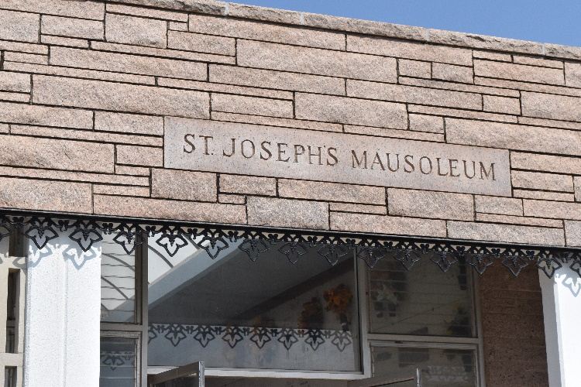

A resident of Gramercy, he died Friday, May 4, 2001, at St. James Parish Hospital in Lutcher. He was 80 and a native of Paulina. Visiting at Sacred Heart of Jesus Catholic Church, Gramercy, from 9 a.m. until Mass of Christian Burial at 11 a.m. Monday. Entombment in St. Joseph Mausoleum. He was the beloved husband of Ella R. Oubre Laiche; father and father-in-law of Rita Ann and Bernard Cambre, Catherine Marie Laiche, Robert W. Laiche Jr., Ronald and Bonnie Laiche, Donald and Phan Laiche and Glenn P. and Deborah Laiche; son of the late Henry and Simidia B. Laiche; brother and brother-in-law of Eve L. and James Long and the late Virginia Laiche Blank; and is also survived by 16 grandchildren and 16 great-grandchildren. H.C. Alexander Funeral Home, Lutcher, in charge of arrangements.
Advocate, The (Baton Rouge, Louisiana)
Saturday, May 5, 2001
Contributed by Jane Edson
**

LAICHE GRAMERCY – Robert Whitmore Laiche Sr., 80, a native of Paulina and resident of Gramercy, died May 4. He was the husband of Ella Oubre Laiche and father of Rita Ann Cambre and Catherine, Robert Jr., Ronald, Donald and Glenn Laiche.He was also the son of the late Henry and Simidia Laiche and brother of Eve Long and the late Virginia Blank.He is also survived by 16 grandchildren and 16 great-grandchildren. Services were May 7 at Sacred Heart Catholic Church, Gramercy, with interment at St. Joseph Mausoleum, Paulina.
L’Observateur, LaPlace, Louisiana
Wednesday, May 9, 2001

