Jeannette (Schexnayder) Lambert
August 29, 1961 – March 14, 2025

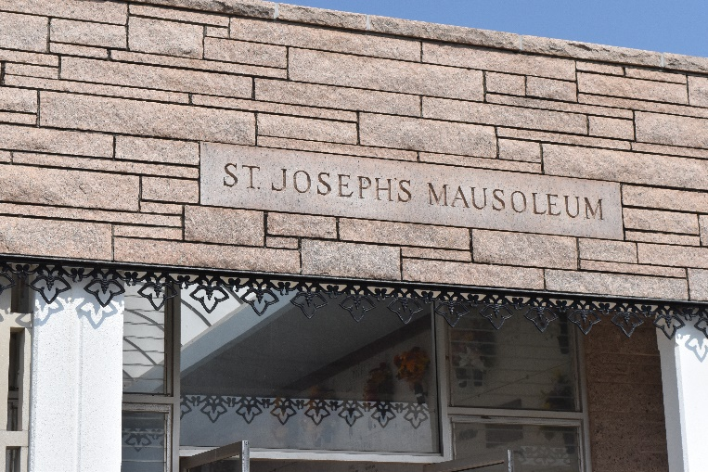

Born on August 29, 1961, and passed away on March 14, 2025 at age of 63. Survived by a son, Adam Joseph Lambert (Jessica); a daughter, Ashley Lambert Simon (Harley); a sister, Odette Schexnayder Vicknair; a brother, Otis Schexnayder, Jr, (Ava); a brother, Charles McCarty (Rosemarie); a grandson, Heath Simon and a loving companion, Paul Babin.
Preceded in death by her husband, Warren Lambert, Jr.; her parents, Otis Schexnayder, Sr. and Shirley Richard Schexnayder; her siblings, Wayne McCarty and her grandson, Brayden Lambert.
Survived by numerous nephews and nieces and loving dog, Beau. She will be greatly missed by all who loved her. She worked as a retail store manager for many years. She loved her family, listening to 60’s and 70’s music as well as Christian music!
Relatives and friends are invited to attend the Visitation and Funeral Service at Rose Lynn Funeral Home,1870 Cabanose Ave., Lutcher, LA. Visitation will be held on Wednesday, March 19, 2025 from 5:00 p.m. until 8:00 p.m. and on Thursday from 9:00 a.m. until 11:00 a.m. followed by a Funeral Service at 11:00 a.m. with services by Grace Church, Pastor Larry Rocquin. Burial in St. Joseph Mausoleum, Paulina, LA.

Rose Lynn Funeral Home, Lutcher, Louisiana
April 2, 2025

