James W. LeBlanc
April 5, 1942 - January 25, 2025

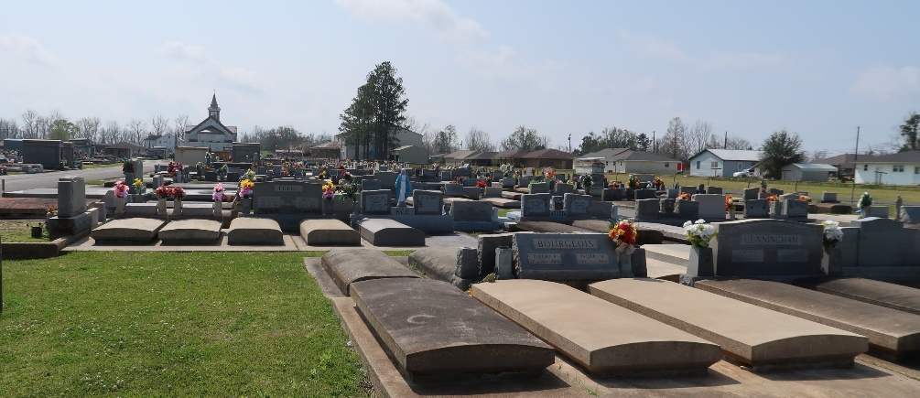

James W. LeBlanc passed away on Saturday, January 25, 2025, at the age of 82. He was born in Lutcher, LA and was a resident of Paulina, LA.
He leaves behind his beloved wife Elizabeth Becnel LeBlanc of 60 years. Loving father of Lynette Bourgeois (Ricky), Stacy Bourgeois (Brian) and Candy Dottolo (David). Grandfather of Richard Bourgeois Ill (Dale), Nicholas Bourgeois (Erin), Meagan Milazzo (Vincent) Kaitlyn Thompson (Colby), Victoria Vicknair (Zack) and Noah Dottolo. Great Grandfather of Bryden, Brax, Natalie, Blythe, Brooks, Brady, Josie, and Remi.
He was the son of the late Dudley Emile LeBlanc, Sr. and Therese Leiche LeBlanc. Brother of Theresa Roussel (the late Richard), Linda Poche, Jessie LeBlanc (Robbin), Terry LeBlanc (Gretchen) and the late Elaine and Aubrey St. Pierre and the late Dudley and Ronnie LeBlanc. He was the father-in-law to Danny Vicknair and the late Ryan Bourgeois. He was also survived by numerous nieces, nephews, and cousins.
Jimmy graduated from Lutcher High School Class of 1960. He proudly served in the United States Army for 6 years. He worked at Kaiser Aluminum for 35 years where he retired. Jimmy enjoyed the great outdoors. You could always find him running dogs, hunting deer, rabbit or squirrels, gardening or at his camp on Blind River.
His legacy of hard work, integrity and unwavering commitment lives on through generations of his family and the countless Lives he has touched. He will be remembered not only for his accomplishments but for the kindness, wisdom and dedication he brought to every aspect of his life. His memory will be lovingly cherished and deeply missed by all who knew him.
The family wishes to thank Kimberly, Lindy, Tamara and Kristi with Modern Home Health and Sonya Badon with Best Care Services for their care and support.
Relatives and friends are invited to attend the Visitation on Thursday, January 30th, 2025, at St. Joseph Catholic Church, 2130 Rectory St., Paulina from 9:00 a.m. to 11:00 a.m. followed by a Funeral Mass at 11:00 a.m. Interment in St. Joseph Cemetery, Paulina, LA.
In lieu of flowers, please send donations to the Dementia/Alzheimer's Association through their official website: www.alz.org

Rose Lynn Funeral Home, Lutcher, Louisiana
January 31, 2025

