Janis (Lambert) LeBlanc
August 5, 1935 - January 13, 2025

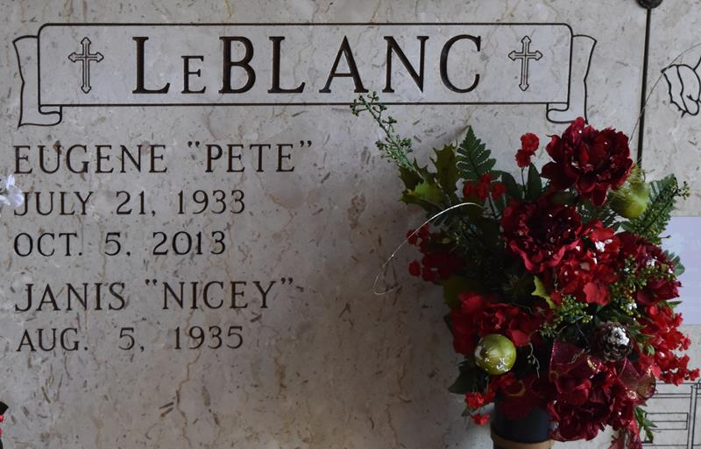

**** DUE TO INCLIMANT WEATHER SERVICE DATE HAS CHANGED
FROM TUES., JAN. 21ST TO THURS., JAN. 23RD****

Janis Lambert LeBlanc, a lifelong resident of Lutcher, passed away on Monday, January 13, 2025 at the age of 89.
Beloved wife of the late Eugene “Pete” LeBlanc. Daughter of the late Joseph Lambert and Adela Dupuis Lambert. Sister of Catherine LeBlanc (the late Clifford) and the late Tilly Maiorana (the late Sal), Lowell Lambert (Janice), Janet LeBlanc (the late Ferdie, Sr.), Mary Frances Veron (the late Ernest), and Sylvia Lambert. Also survived by numerous nieces, nephews, and friends.
Relatives and friends are invited to attend the Visitation and Funeral Mass at St. Joseph Catholic Church, 2130 Rectory St., Paulina on Thursday, January 23, 2025. Visitation will be held at the church from 9:00 a.m. to 11:00 a.m. followed by a Funeral Mass at 11:00 a.m. Interment in St. Joseph Cemetery, Paulina, LA.
The family would like to thank all the staff of Chateau St. James, for their excellent care they provided, for over 6 years.

Rose Lynn Funeral Home, Lutcher, Louisiana
January 19, 2025

