James William Pollard
July 29, 1948 - October 17, 2024

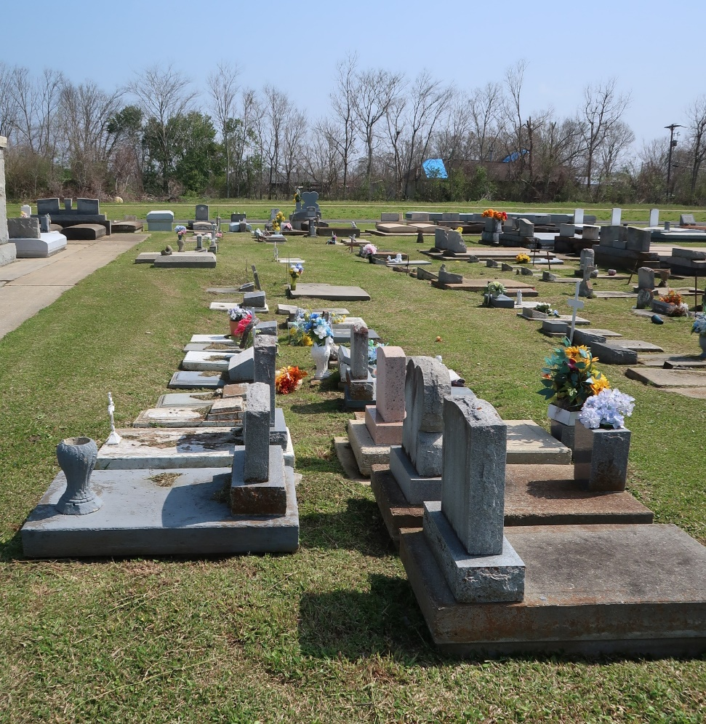

James William Pollard passed away on Thursday, October 17, 2024 at the age of 76. He was born in and a resident of Lutcher, LA.
Son of the late Ruby Louque Pollard and William Amberson Pollard. Brother of Patty P. Culver (the late Ivan) and the late Peter Edward Pollard and Dennis Charles Pollard. Also survived by nieces and nephews.
Relatives and friends are invited to attend the Visitation and Memorial Mass at St. Joseph Catholic Church, 2130 Rectory St., Paulina on Thursday, October 24, 2024. Visitation will be held at the church from 9:00 a.m. to 11:00 a.m. followed by a Memorial Mass at 11:00 a.m. Interment in St. Joseph Cemetery, Paulina, LA.
Rose Lynn Funeral Home, Lutcher, Louisiana
October 19, 2024

