William Thomas Rouillier
March 29, 1980 - January 7, 2025

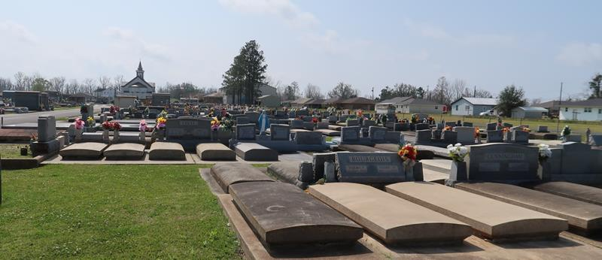

William “Billy” Thomas Rouillier passed away on Tuesday, January 7, 2025 at the age of 44. He was born in New Orleans, LA and a resident of Paulina, LA.
Beloved son of Debra Rouillier and Thomas Rouillier. Brother of Angela Bell (Heath) and Leslie Guilbeau (Brent). Uncle of Hayden, Lauren, Julianna and Evan.
Billy loved to cook and hangout with his dog Buddy. He was very generous, as he would constantly give his coat and umbrella to those less fortunate.
Relatives and friends are invited to attend the Visitation and Funeral Mass at St. Joseph Catholic Church, 2130 Rectory St., Paulina on Thursday, January 9, 2025. Visitation will be held at the church from 9:00 a.m. to 11:00 a.m. followed by a Funeral Mass at 11:00 a.m. Interment in St. Joseph Cemetery, Paulina, LA.
Rose Lynn Funeral Home, Lutcher, Louisiana
January 13, 2025

