Hennis Joseph Roussel, Sr.
November 16, 1949 - April 5, 2025

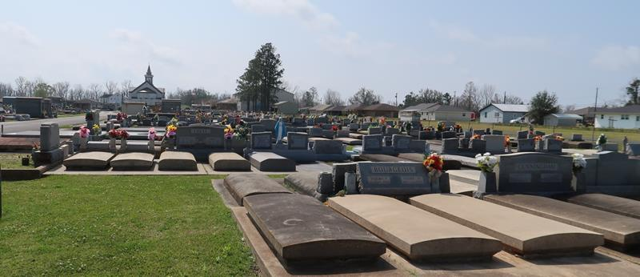

It is with great sadness that the family of Hennis “Bubba” Joseph Roussel, Sr. announces his passing on April 5, 2025, at Ochsner Kenner Hospital at the age of 75. A resident of Lutcher, Louisiana, Bubba was known for his storytelling, sense of humor, and love of life.
Bubba is survived by his sons, Jeffrey Roussel, Brian Roussel (Valerie), and Craig Roussel; his daughter, Julie Gilbert (Travis); and his beloved grandchildren, DeAnna Gilbert, Brodie Gilbert, and Brendon Roussel. He is also survived by his brothers, Dennis (Gaynell), Jerry (Julie), Terry (Melissa), Kent (Laurie), and Brent Roussel; his sister, Violet Roussel; and numerous nieces and nephews.
He was preceded in death by his wife, DeAnna Guedry Roussel; his eldest son, Hennis Roussel, Jr.; and his parents, Allen and Violet Roussel.
Bubba was a proud graduate of Lutcher High School, Class of 1967. He married the love of his life in 1969 and spent much of his career at Kaiser and Larouche Industries. Bubba’s true passion, however, was his family. He found great joy in spending time with his children and grandchildren, and he always cherished family gatherings. Bubba also loved card games, dancing, and sports, and he could often be found making people laugh with his quick wit and humorous stories.
A visitation in his memory will be held on Thursday, April 10, 2025, at St. Joseph Catholic Church in Paulina, LA, from 8:00 a.m.-9:00 a.m. for family; 9:00 a.m. until the funeral service at 11:00 a.m. for friends, followed by a Mass of Christian Burial. Interment will follow at St. Joseph Catholic Church Cemetery.
The family extends their heartfelt thanks for the love and support shown during this difficult time. Bubba will be deeply missed by all who knew and loved him.

Rose Lynn Funeral Home, Lutcher, Louisiana
April 10, 2025

