Robin (Duhe) Roussel
May 5, 1954 - January 7, 2025

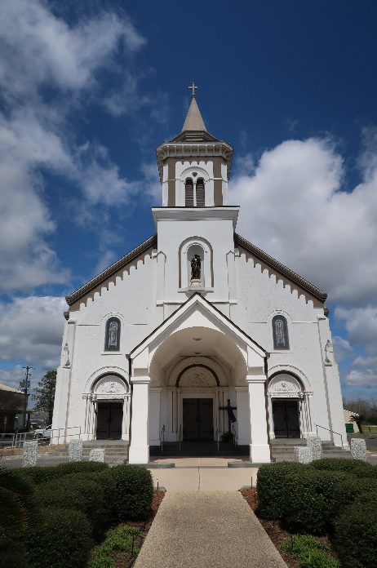

Robin Duhe Roussel passed away on Tuesday, January 7, 2025 at the age of 70. She was raised in Reserve and a resident of Paulina, LA.
Robin was an honorary member of The Catholic Daughters of the Americas, St. Joseph Chapter and volunteered at St. Vincent de Paul Society in Lutcher, LA. She loved spoiling her grandchildren and spending as much time with them as possible.
Beloved wife of Bruce “Bootsy” Joseph Roussel. Loving mother of Amanda Downing (Arthur) and Devin Roussel (Kristen). Grandmother of Adalynn, Ashton, Tucker, and Phoebe. Daughter of the late Freddie Duhe, Sr. and Nellie Hottel Duhe. Sister of Mark “Eddie” Duhe (April), Dennis Duhe (Allison), Margaret Pruitt (Paul), Andy Duhe (Greta) and the late Freddie Duhe, Jr. (Pam), Mary St. Martin (the late Johnny), and Timmy Duhe. Also survived by numerous nieces, nephews, and cousins.
Relatives and friends are invited to attend the Visitation and Funeral Mass at St. Joseph Catholic Church, 2130 Rectory St., Paulina on Monday, January 13, 2025. Visitation will be held at the church from 9:00 a.m. to 11:00 a.m. followed by a Funeral Mass at 11:00 a.m. Interment in St. Joseph Cemetery, Paulina, LA.

Rose Lynn Funeral Home, Lutcher, Louisiana
January 13, 2025

