Annabelle Ann (Zeringue) Schexnayder
August 13, 1938 - February 27, 2025

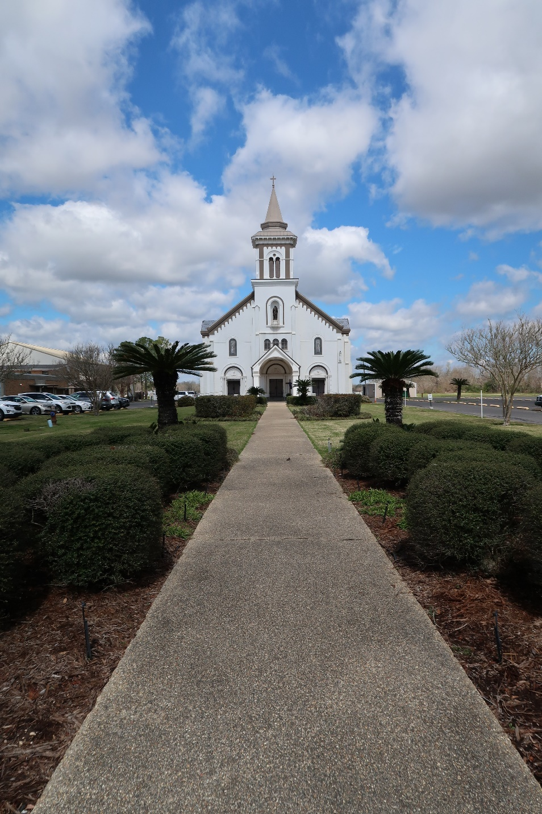

Annabelle Ann Zeringue Schexnayder, a lifelong resident of Gramercy, passed away on Thursday, February 27, 2025, at the age of 86.
Beloved wife of the late Randall Schexnayder. Loving mother of Wendy Poche (Neal), Trudy LeBlanc(the late Danny), Damian Schexnayder, and the late Randy Schexnayder (the late Susie). Grandmother of Meghann Roper (Jeremy), Jade Joffrion (Jake), Melissa Roper, Luke LeBlanc (Sydney), Neal Poche, III, and Michaela Poche. Great-grandmother of Madyson Roper, Tate Roper, Brady Roper, Rowan Roper, and Bentley Roper. Daughter of the late Arcade Zeringue and Elise Dufrene Zeringue. Sister of Donna Vicknair, the late Grace Faucheux, Myrtis Lambert, Hazel Guidry, Elsie Guidry, Gloria Zeringue, Pete Zeringue, Harry Zeringue, and Ray Zeringue. Also survived by numerous cousins, nieces and nephews.
Annabelle was a devoted and loving wife for 50 years. She was a Eucharistic Minister at Most Sacred Heart Church and a devoted adorer at the Lutcher Chapel. She was an excellent cook, always hosting Sunday family dinner. She loved to watch football, live or reruns.
Relatives and friends are invited to attend the Visitation and Funeral Mass at Most Sacred Heart of Jesus Church, 616 E. Main St., Gramercy on Friday, March 7, 2025. Visitation at the Church from 9:00 a.m. to 11:00 a.m. followed by a Funeral Mass at 11:00 a.m. Interment in St. Joseph Cemetery, Paulina, LA.

Rose Lynn Funeral Home, Lutcher, Louisiana
Sunday, March 2, 2025

