Terry Lionel Storks
August 9, 1948 - February 12, 2025

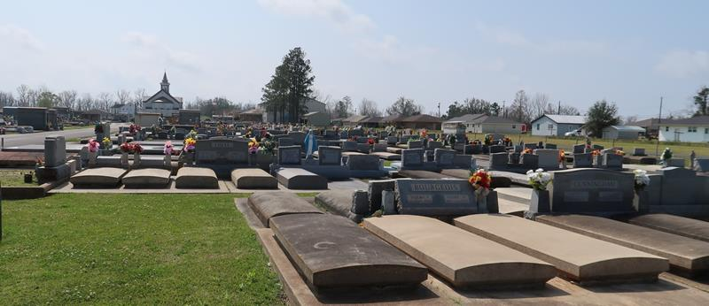

Terry Lionel Storks, the 3rd child of Doretha and Wilburt Storks, was born in New Orleans, Louisiana on August 9, 1948. Terry was raised by God-fearing women and men and accepted God at an early age. In his younger years, he was a member of King David Baptist Church. Later in life, he became a minister at New Mt. Zion Baptist Church in Dallas, TX under the tutelage of Rev. Robert Price and later Dr. Tommy L. Brown.
Terry leaves to cherish his memory his wife Rita and her four daughters (Tera (Shawn) , Lyssa (Brad), Kristin, Adrienne (Mike); seven grandchildren and one great grandson; his sisters Laura Storks (and her family); Jocelyn Dennison Johnson (and her family); son Dwan Storks; grandson Pierce Ellis; and other family and friends who he thought of with love and fond memories.
Terry was preceded in death by his mother Doretha Storks; father Wilburt Storks; daughter LaKeysha Storks; brother Norman Storks, Jr; and sister Beverly Storks.
A public visitation will be held on Thursday, February 20, 2025 from 4-6pm at Treasures of Life Funeral Services, 315 E. Airline Hwy., Gramercy, LA 70052. A celebration of life, love and legacy will be held on Friday, February 21, 2025 for 10am at St. Mark Baptist Church, 132 Marquez St., Mt. Airy, LA 70076. No visitation on the day of service. Interment St. Joseph Catholic Church Cemetery, 2130 Rectory St., Paulina, LA 70763.

Treasures of Life Funeral Services, Gramercy, Louisiana
Sunday, February 23, 2025

