Lynn Edward Trosclair
July 26, 1942 - March 26, 2025
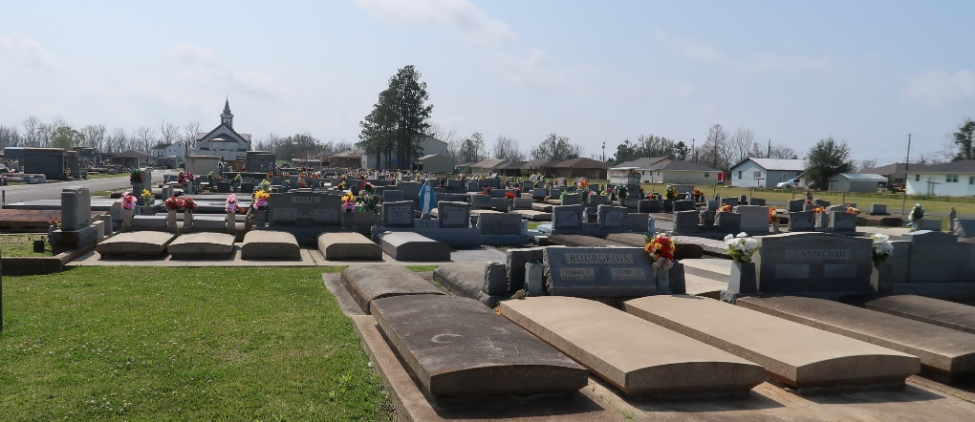

Lynn Edward Trosclair, a resident of Gramercy, passed away on Wednesday, March 26, 2025 at the age of 82.
Beloved husband of Patricia “Pat” Louque Trosclair for 62 years. Loving father of Brett Trosclair (Tracie), Tricia Allen (Dan), and the late Roy Trosclair. Grandfather of Kristie, Brittny, Jessica, Ashley, Brandy, Caiden, Peyton, James, Janie, Josie, and Corie. Great-grandfather of Hudson, Jalan, McKenzie, and Adalynn. Son of the late Royal Trosclair and Mildred Landry Trosclair. Brother of Nancy Jacob (the late Andre) and the late Robert “Bobby” Trosclair. Uncle of Dr. Ryan Jacob.
Relatives and friends are invited to attend the Visitation and Funeral Mass at St. Joseph Catholic Church, 2130 Rectory St., Paulina on Monday, March 31, 2025. Visitation will be held at the church from 9:00 a.m. to 11:00 a.m. followed by a Funeral Mass at 11:00 a.m. Interment in St. Joseph Cemetery, Paulina, LA.
Rose Lynn Funeral Home, Lutcher Louisiana
April 1, 2025

