Sandy (Martin) Weber
July 27, 1964 - November 23, 2024

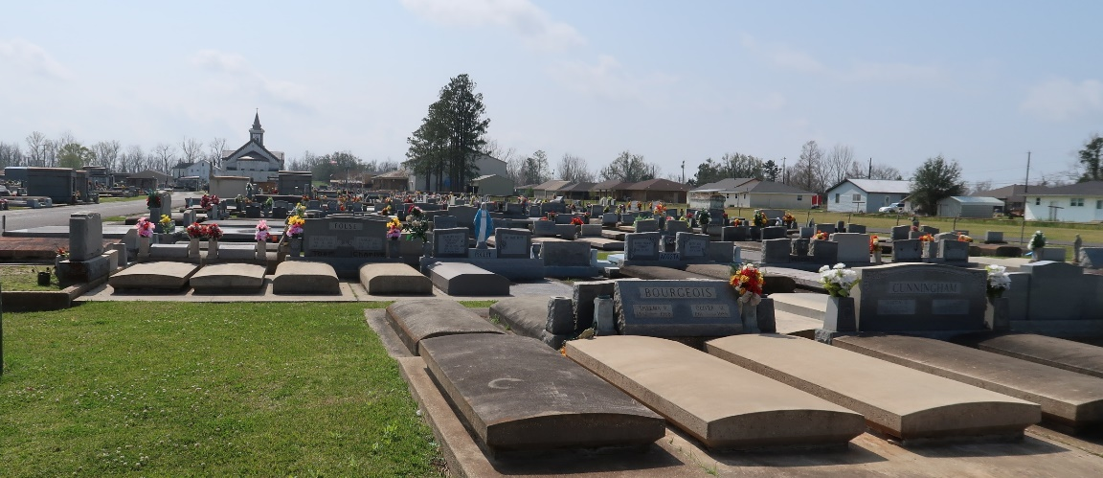

It is with profound sadness that we announce the passing of our beloved Sandy Martin Weber. After receiving a Stage IV rectal cancer diagnosis in 2021, Sandy went on to courageously fight this awful disease with so much bravery and courage. Her strong will to live, unwavering faith in God, and the love and prayers of family, friends, and many supporters carried her through until she peacefully passed away in her home on Saturday November 23, 2024, surrounded by her closest family and friends. She was 60 years old.
She leaves behind her husband of 38 years, Troy M. Weber; her daughter, Paige Weber Bergeron (Chance); and her two precious grandbabies Brady Glynn Bergeron (3) and Annie Bernice Bergeron (1). Her grandchildren meant the world to her and she often told others that they were "the best medicine."
She is the daughter of the late Bernice Matherne Martin and late Marc J. Martin. She is survived by her siblings, Carolyn Ann Martin, Barbara Ann Roussel (Ricky), Mark J. Martin Jr. (Raynette), Ricky Paul Martin (Claire), Wanda Cecile Bienvenu (Tommy), Kenny Joesph Martin, and the late Mary Ann Roques (Nelson). She is preceded in death by her father-in-law Glynn Weber (Carolyn) and survived by her sister-in-law Roxanne Greaud.
Sandy married her high school sweetheart Troy on December 5, 1986. After moving to Panama City Beach, FL for some time, the couple moved back to Paulina, LA where they would have their daughter Paige in 1990. They went on to make a lifetime of memories as a family. Being present for the births of both of her grandchildren was something that she made sure to thank God often for.
She worked for Roussel's Land-Care Services, formally Roussel's Garden Express for 24 years. She was a very dedicated employee and took so much pride in making sure the business ran smooth. She poured her heart and soul into the business and worked full-time until she needed to stay home to focus on her health.
Throughout her life she maintained a sweet and simple demeanor that won the trust and hearts of many, who even now are being changed by her witness of constant nurturing love and faith.
The family is deeply grateful for the outpouring of love, prayers, and support. We would like to thank all the nurses and staff at Mary Bird Perkins Cancer Center for the amazing care that was given to us in the last few years. We would also like to thank Compassus Hospice – specifically Katie, Shea, and Ashley for everything that was done to make her comfortable in her final days.
Last, but far from least, we want to give a very heartfelt thank you to her compassionate oncologist Dr. Daniel Lavie and his nurse practitioner Julie Gomez. There are not enough words to adequately express how much we appreciate the knowledge and outstanding care that was provided by them. We could not have asked for a better team of healthcare professionals.
Relatives and friends are invited to attend the Visitation and Funeral Mass at St. Joseph Catholic Church, 2130 Rectory St., Paulina on Monday December 2, 2024. Visitation will be held at the church from 9:00 a.m. to 11:00 a.m. followed by a Funeral Mass at 11:00 a.m. and interment in St. Joseph Cemetery.
In lieu of flowers, please consider donating to the Colon Cancer Coalition, a non-profit organization that was near and dear to her heart.

Rose Lynn Funeral Home, Lutcher, Louisiana.
November 26, 2024

