Ray Anthony White
June 29, 1954 – February 25, 2001

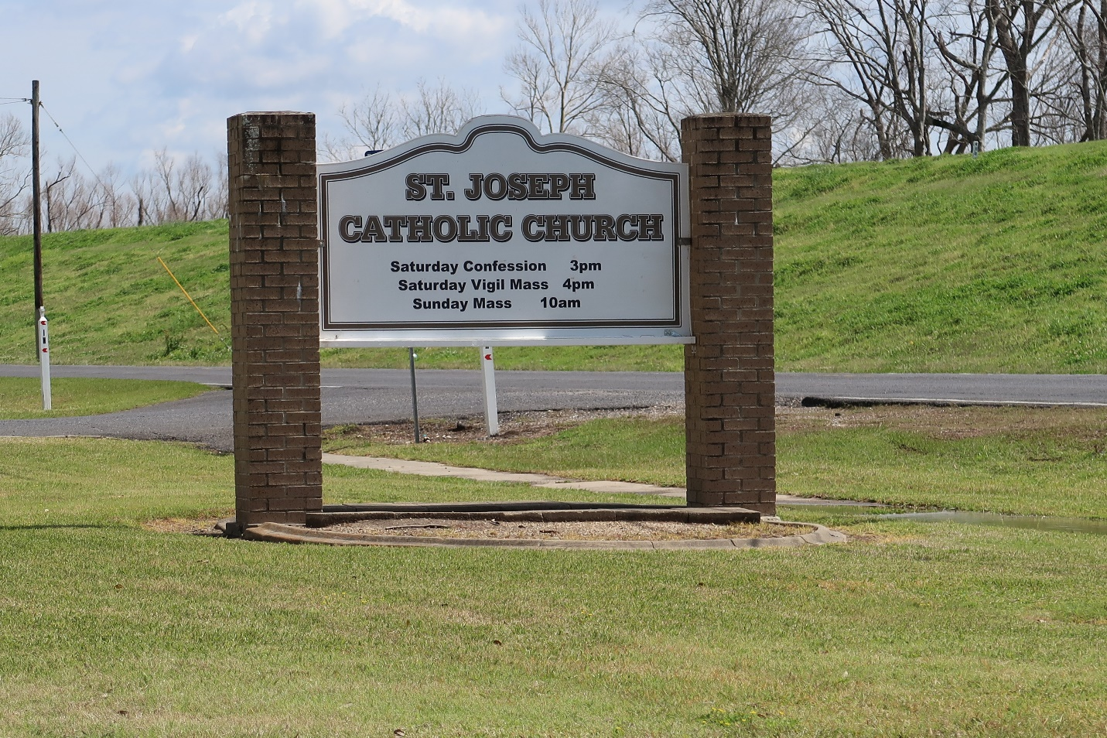

WHITE DONALDSONVILLE – Ray Anthony White, 46, a native of Lutcher and resident of Donaldsonville, died Feb. 25. He was the husband of Sherry A. White and father of Darnelle Holland, Demond Daigre, DesKameko Davare and Kai, Rashonda and Jamaal White. He was also the son of Edward and Gloria White and brother of Shelia Jackson, Shantel and Kenneth White and the late Angel Love. He is also survived by two grandchildren. He was a licensed clinical social worker with a private practice. Services are today at 11 a.m. at St. Philip Baptist Church, Modeste, with interment at St. Joseph Mausoleum, Paulina. Visitation starts at 10 a.m.
L’Observateur, LaPlace, Louisiana
Saturday, March 3, 2001

