Claire Elizabeth Zeller
April 20, 2000 - November 2, 2024

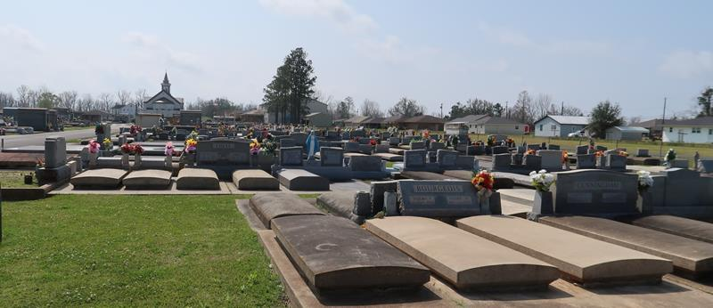

Claire Elizabeth Zeller, a bright soul who touched the hearts of many, passed away on Saturday, November 2, 2024, at the tender age of 24. Born in Baton Rouge, Louisiana, she was a cherished resident of St. Amant.
Claire was the beloved daughter of Karl Michael Zeller and Happy Bourgeois Zeller. Her sister, Alixx Zeller Poche, and brother-in-law, Jared, who shared a close bond with her. She carried the legacy of her grandparents: Carolyn Roussel Bourgeois and the late Paul Anthony Bourgeois, as well as the late Marie Pitarro Zeller and the late Gerald Anthony Zeller. Also survived by her goddaughter Jae Marie Poche and niece Josie Mae Poche, along with many, many aunts and uncles and LOTS of cousins. Their love surrounded her throughout her life.
A 2018 graduate of St. Amant High School, Claire continued her educational journey at Louisiana State University, where she earned a bachelor’s degree in Kinesiology with a concentration in Exercise Science. Her passion for health and wellness led her to become a certified corrective exercise specialist and personal trainer. Claire’s dedication shone brightly during her tenure as the Team Lead and Manager at Moreau Physical Therapy in Zachary, LA.
Outside of work and studies, Claire reveled in life’s simple pleasures. She loved the outdoors, whether it was cheering on LSU football at games and tailgates, attending concerts, feeling the sand between her toes at the beach, or boat riding with family and friends. Claire’s infectious enthusiasm motivated those around her to reach their fitness goals, and she had a remarkable ability to make everyone feel their best self.
Among her greatest joys was being a nanny to her goddaughter, Jae Marie Poche. Tea parties and imaginative playtime with Jae brought laughter and warmth to Claire’s heart. Her niece, Josie Mae Poche (affectionately known as JoJo), held a special place in Claire’s life. And if you knew her, let’s not forget her unwavering love for “Jeeps”.
Claire’s radiant smile, positive energy, and contagious laughter will echo in the memories of all who knew her. She embraced her roles as a daughter, sister, cousin, granddaughter, niece and nanny with grace, but perhaps her most cherished title was that of a friend. “Clairebear,” as she was affectionately called, leaves behind a legacy of kindness, joy, and unwavering friendship.
Relatives and friends are invited to attend the Visitation and Funeral Mass at St. Joseph Catholic Church, 2130 Rectory St., Paulina on Friday, November 8, 2024. Visitation will be held at the church beginning at 8:30 a.m. followed by a Funeral Mass at 12:00 p.m. Interment in St. Joseph Cemetery, Paulina, LA.
In lieu of flowers, donations can be made in Claire’s Memory to St. Jude Children’s Research Hospital at www.stjude.org

Rose Lynn Funeral Home, Lutcher, Louisiana
November 9, 2024

