Dan Anthony

Abt. 1956 - March 7, 2005

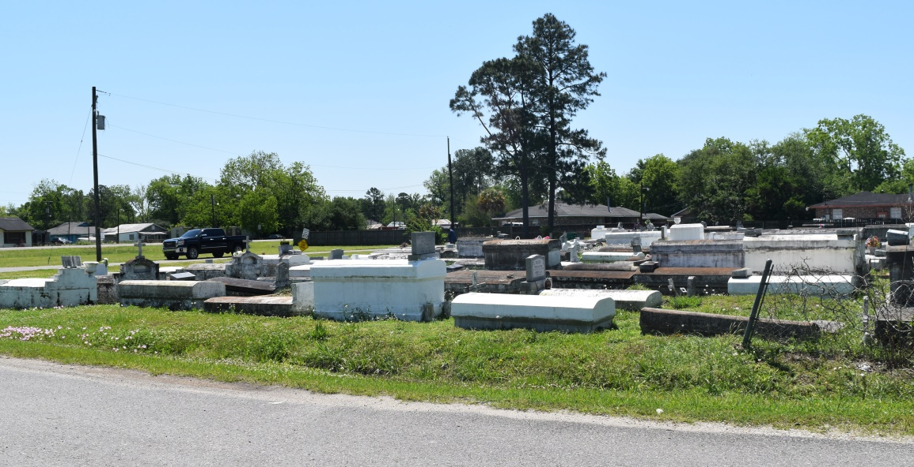

Dan Anthony on Monday, March 7, 2005. Son of the late Thomas Anthony, Sr. and Thelma Fleming Anthony. Father of Danielle A. Fox of Memphis, TN and Quiana A. Jones of New Orleans, LA. Brother of Barbara Jean Anthony, Robert Anthony and the late Thomas "Pappy" Anthony, Jr. Grandfather of Tramaine Fox, Cardaryl, Joshua and Derrick Jones, Jr. Also survived by a host of nieces, nephews, cousins, other relatives and friends. Age 49 years. A native and resident of LaPlace, LA.  
  
Relatives and friends of the family are invited to attend the Funeral Services from ROBOTTOM MORTUARY, 850 Highway 44 (River Road), Reserve, LA on Friday, March 11, 2005 at 11:00 a.m. Interment Bethlehem Cemetery, Reserve, LA. Visitation at the above named funeral home on Friday from 9:00 a.m. until service time.  
  
SERVICED BY ROBOTTOM

**Times-Picayune, The (New Orleans, LA) - Thursday, March 10, 2005**

**Contributed by Jane Edson**