Shirley (Frank) Carter

July 10, 1948 – December 24, 2017

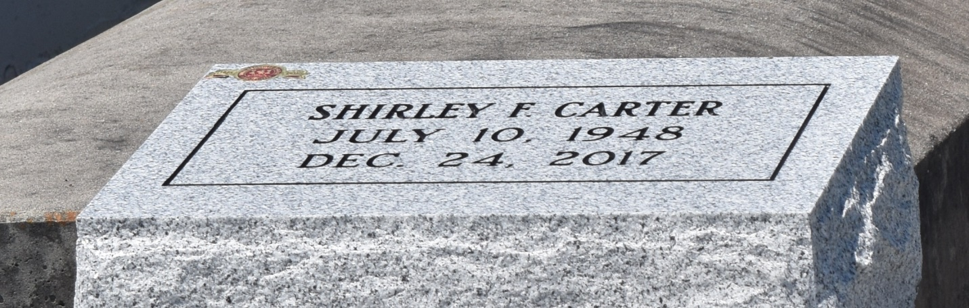

Shirley Frank Carter at the age of 69 years departed this earthly life and entered into eternal rest on Sunday December 24, 2017, at her residence in Reserve, La. She was a member of Bethlehem Missionary Baptist Church of Reserve, La. Shirley was the daughter of the late Hilda Cantrell Frank and Peter Frank Sr. Beloved Mother of Kenneth Carter (Zyiesha) of LaPlace, La., Wardell Carter (Danielle) of LaPlace, La., and Travis Carter (Tanisha) of Reserve, La. The love of her life Michael Lestrick, who took care of her until her death. Her loving sisters Ethel Forest and Louise Brown of LaPlace, La., Gloria Lestrick and Mary Lee Jones of California. Devoted friends: Elizabeth Francois, Danielle and Darnell Frank. Also survived by nine grandchildren, two great-grandchildren, a host of nieces, nephews other relatives and friends. Shirley was preceded in death by her parents Hilda and Peter Frank Sr.; sisters: Emma Sanders, Alma Toney, Dora Sylvain, Augustine Frank, and Rosa Lee Jones; brothers: Peter Frank Jr. and Ishmel Frank Sr.

Pastors, Officers and Members of Bethlehem Missionary Baptist Church of Reserve, La., and all neighboring churches are invited to attend the home-going celebration on Wednesday January 3, 2018, at 11:00am at the Bethlehem Missionary Baptist Church, 146 East 20th St., Reserve, La. Pastor Forell Bering officiating. Interment in Bethlehem Church Cemetery. Visitation at the above name church from 9:00am until service time. Bardell's Mortuary of Mt. Airy, La., in charge. Information: 985-535-6837.

**Downloaded from legacy.com 4/30/2018**