Verna Mae Cosey

June 4, 1931 – April 29, 2006

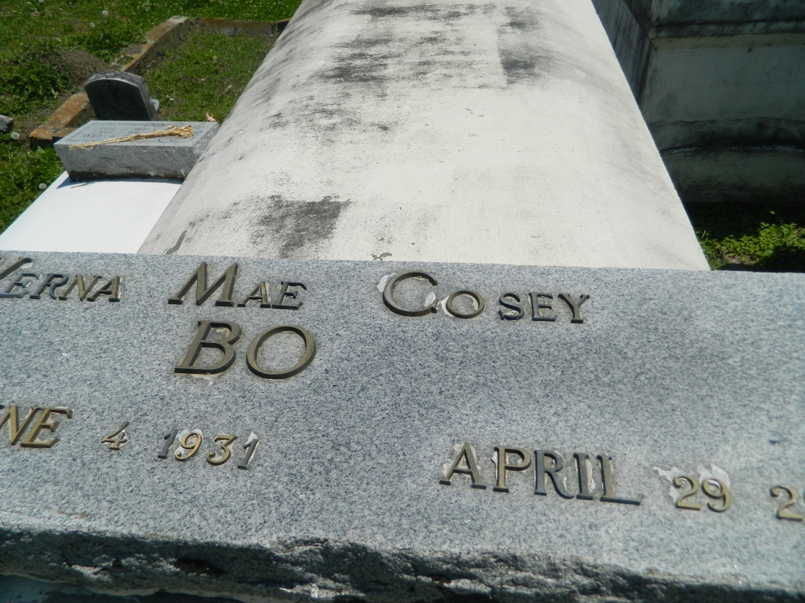

RESERVE - Verna Mae Cosey, 74, a native and resident of Reserve, died April 29.  
  
She is survived by her children Robert Porter, Ann Marie White and Wendy Smith, Merkadell, Veris, Andrew and Angelina Cosey.  
  
She is also survived by 27 grandchildren, 12 great-grandchildren, four godchildren and two sons-in-law.

Services will be held today at 11 a.m. at Rescue Mission Baptist Church, Reserve, with interment in Bethlehem Cemetery, Reserve.  
  
Hobson Brown Funeral Home of Garyville is in charge of arrangements. Visitation begins at 9 a.m. at the church.

**L'Observateur (La Place, LA) - Monday, May 8, 2006**

**Contributed by Jane Edson**