Howard Craighead Sr.

Abt. 1946 – January 17, 2003

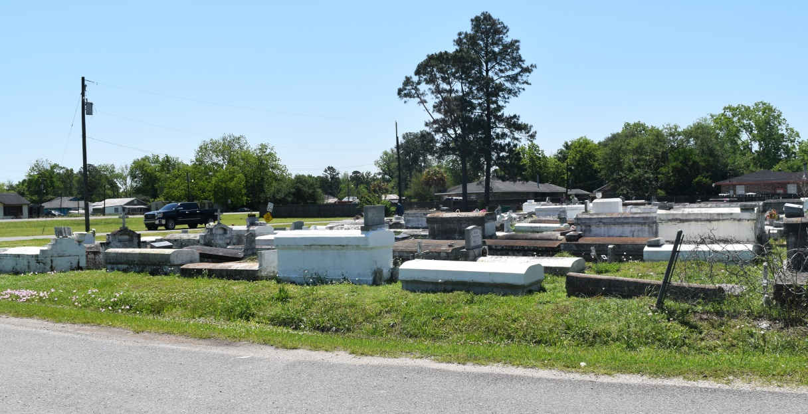

GARYVILLE – Howard Craighead Sr., 57, a native and resident of Garyville, died Jan. 17.

He was the husband of Karen James Craighead and father of Ebonee, Romalish and the late Howard Craighead Jr.

He was the son of the late Robert and Roseanne Craighead and brother of Willie Mae Joseph, Dorothy Mae Howard, Glendora Warren and Edward Sr., the Rev. Robert Jr., the Rev. Erwin and Barbara Craighead.

He is also survived by seven grandchildren and two great-grandchildren.

Services are today at noon at Greater New Mt. Zion Baptist Church, Garyville, with interment at Bethlehem Cemetery, Reserve. Visitation starts at 10 a.m.

L’Observateur, LaPlace, Louisiana

Tuesday, January 28, 2003