Beatrice (Johnson) Della

October 16, 1919 – June 23, 2002

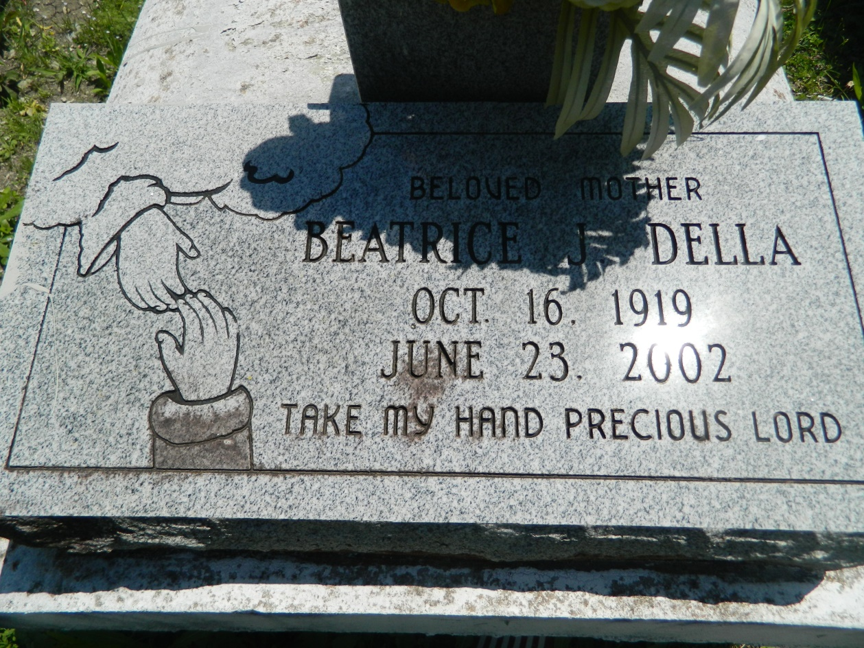

Beatrice Johnson Della, a retired cook, died Sunday at East Jefferson General Hospital. She was 82. Mrs. Della was a lifelong resident of Reserve. She was a deaconess at New Pilgrim Baptist Church. Survivors include four sons, James, Wilfred, Oscar and Bartley Della; seven daughters, Rose Creecy, Audrey Mizell, Anna L. Della, Gloria Della, Carolyn Leon, Connie Della and Shenetta Brown; two sisters, Sydonia Lewis and Ruth James; 38 grandchildren; and 30 great-grandchildren. A funeral will be held Friday at 11 a.m. at New Pilgrim Baptist Church, 107 Pilgrim Drive in Reserve. Visitation will begin at 9 a.m. Burial will be in Bethlehem Baptist Church Cemetery. Baloney Funeral Home is in charge of arrangements.

**Times-Picayune, The (New Orleans, LA) - Thursday, June 27, 2002**

**Contributed by Jane Edson**