James Della Sr.

February 21, 1941 – January 10, 2003

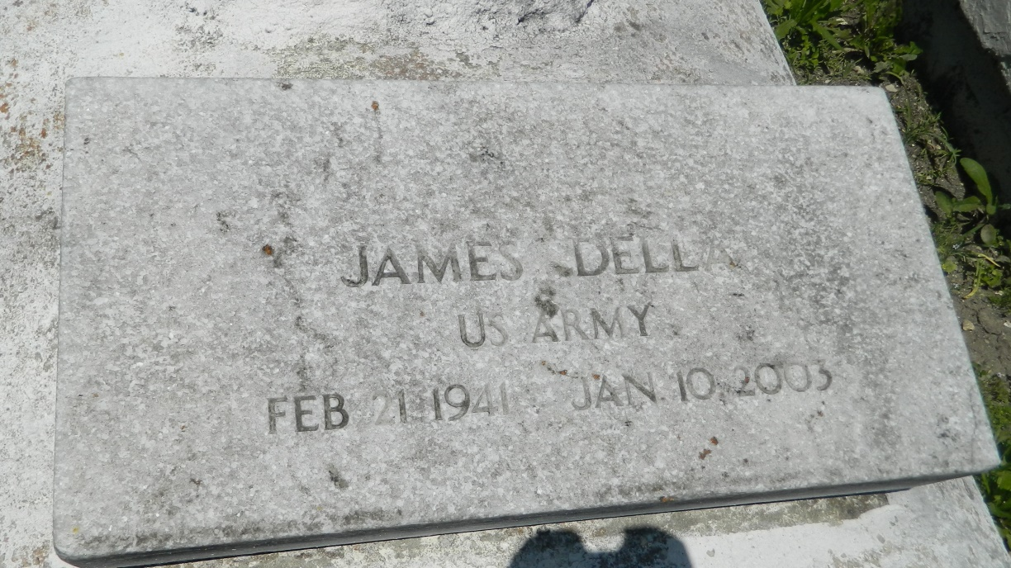

MT. AIRY - James Della Sr., 61, a native of Reserve and resident of Houston, died Jan. 10. He was the companion of Lillie Peters, father of Michelle LeVigne and James Della Jr. and stepfather of Rodney, Gregory and Ollie Peters. He was the son of the late Oscar Sr. and Beatrice Johnson Della and brother of Rose Creecy, Audrey Mizelle, Carolyn Leon, Shanetta Brown and Anna, Wilfred Sr., Gloria, Connie, Oscar Jr. and Bartley Della.  
  
Memorial services are today at 11 a.m. St. John the Baptist Church, Mt. Airy, with interment at Bethlehem Cemetery, Reserve. Visitation starts at 9 a.m.

**L'Observateur (La Place, LA) - Tuesday, January 21, 2003**

**Contributed by Jane Edson**