Octavia (Williams) Dorsey

November 26, 1916 – May 8, 2015

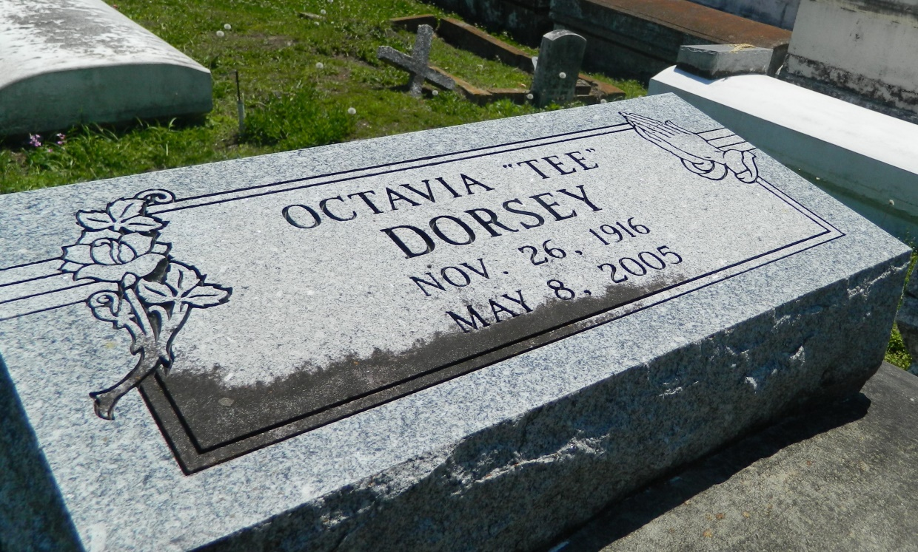

GARYVILLE - Octavia "Tee" Dorsey, 89, a native and resident of Garyville, died May 8. She was the wife of the late Ferdinand Dorsey Sr.  
  
She is survived her step-child Joel Allen.  
  
She is also survived by niece Claudia K. Schexnayder and grandson Kevin Allen.  
  
She was preceded in death by her parents Jonas and Virginia James Williams, son Ferdinand Dorsey Jr., siblings Rose Minor Knight and Kelly Williams and nephew Eunice Williams.  
  
Services were held May 12 at True Light Baptist Church, Garyville, with interment in Bethlehem Baptist Church Cemetery, Reserve.

**L'Observateur (La Place, LA) - Monday, May 15, 2006**

**Contributed by Jane Edson**