Robbie Mark Duhe

November 3, 1958 – October 4, 2009

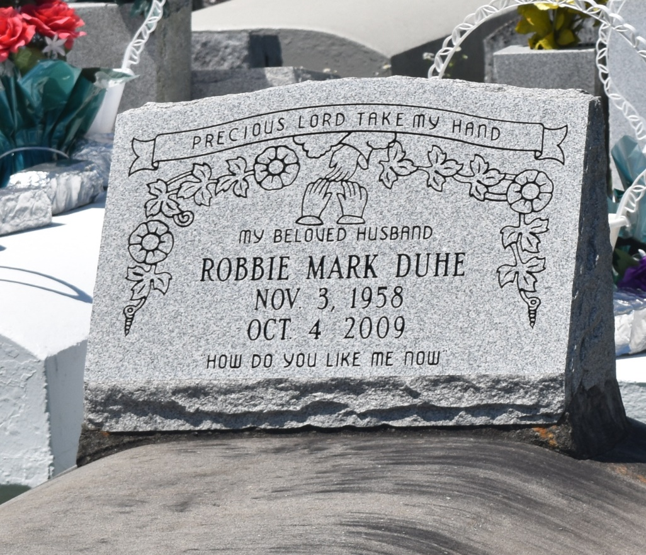

Robbie Mark Duhe, age 50, departed this life on Sunday, October 4, 2009 in LaPlace, La. Son of the late Marjorie and Clarence Duhe, Sr. Devoted husband of Ora Lee Duhe. Father of Pamela Barre, LaHa Grows, and Anthony Breaux. Brother of Clarence Duhe, Jr., Melanie Hill, Terrance Jones and the late Garland Duhe. Nephew of Ethel Paxton, Gail François, Edgar Jones, Henry Rose, and Donald Mitchell. Survived by: 1 great-aunt Audrey Hart, 2 great-uncles Williams and Mark Mitchell and, 1 devoted aunt Eva Stewart. Also survived by 7 grandchildren, a host of nieces, nephews, other relatives and friends. A native and resident LaPlace, La.  
  
Service will be Saturday, October 10, 2009 at Milesville Memorial Church of God in Christ, 129 Apple St., LaPlace La. at 10:00 a.m. Bishop Ronald Frank, Officiating. Burial in Bethlehem Cemetery, Reserve, La. Viewing at the Church on Friday from 6:00 p.m. Until 8:00 p.m. and on Saturday from 9:00 a.m. until service time. (ONLY)  
  
Service Entrusted to Hobson Brown Funeral Home, Garyville, La. (985) 535-2516

**Times-Picayune, The (New Orleans, LA) - Friday, October 9, 2009**

**Contributed by Jane Edson**