Betty L. Evans

Abt. 1948 - December 7, 2000

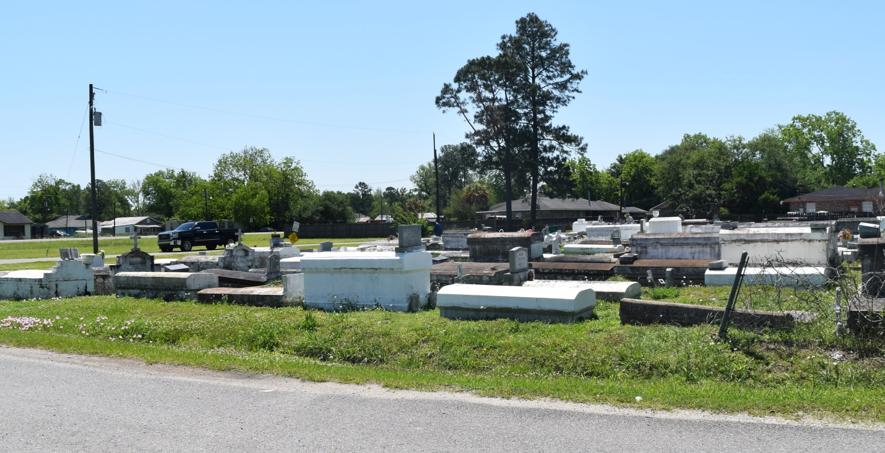

EVANS

RESERVE - Betty L. Evans, 52, a native and resident of Reserve, died Dec. 7. She was the mother of Tracey and Stacey Turner. She was also the daughter of the late Charley and Ernestine Evans and sister of Audrey Washington, Mary Ann Joseph and Eloise, Willie and Earl Evans. She is survived by one grandchild.

Services are today at 10 a.m. at Bethlehem Baptist Church in Reserve, with interment at the church cemetery.

L'Observateur, LaPlace, LA; December 16, 2000