Leonard Gardner

Abt. 1954 – March 19, 2007

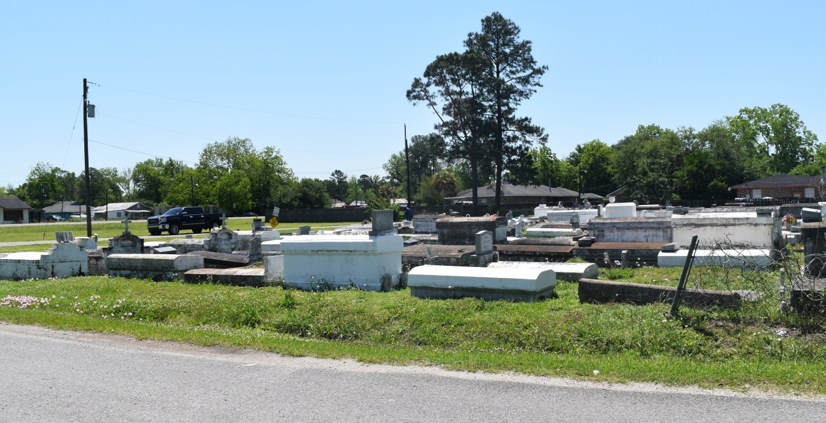

Leonard (Big Eye) Gardner, age 53, departed this life on Monday, March 19, 2007 in Brooklyn, New York. Son of the late Lillian Miles and Robert Gardner. Husband by first marriage of Doretha S. Gardner. Father of Renata (James), Reanda Morris, and Remona Gardner. Two grandchildren: Jaden S. Porter and Romell R. Pack. Survived by three sisters and five brothers, a host of aunts, uncles, nieces, nephews, other relatives and friends. A native of Garyville, La. and a resident of Brooklyn N.Y. for the past 8 years.   
 Relatives and friends of the family, also pastor, officers and members of the First Community Antioch Baptist Church are invited to attend a service on Friday, March 30, 2007 at 2:30pm at The Baloney Funeral Home LLC, 399 Earl Baloney Dr., Garyville, LA. Conducted by Rev. Ferdinand Gaines, Jr. Interment Bishop Cemetery at Marathon, Garyville, La.   
 In charge of arrangements, THE BALONEY FUNERAL HOME LLC, 399 Earl Baloney Dr., Garyville, LA. 70051  985-535-2540   
  
**Times-Picayune, The (New Orleans, LA) - Friday, March 30, 2007**

**Contributed by Jane Edson**