Lucien Warren "Billy" Jacob Sr.

January 19, 1942 – March 26, 2018

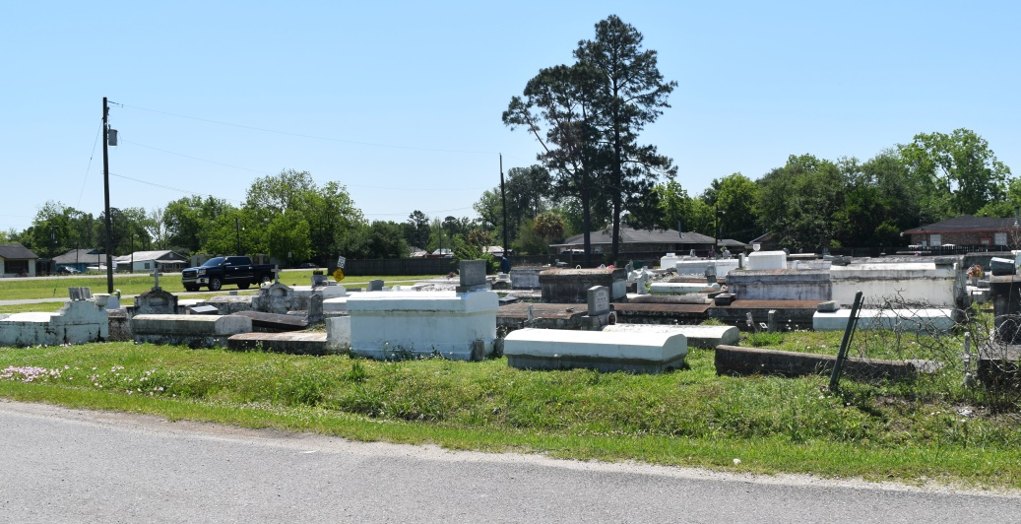

1942 – 201JaJann8

Lucien Warren “Billy” Jacob Sr. for God’s own purpose and according to his perfect will was born on January 19, 1942 to the parentage of the late Morgan L. and Dorothy Jackson Jacob entered into an eternal rest on March 26, 2018. A native of LaPlace and a resident of New Orleans, La. He spent a large part of his early years in Chicago, Illinois. After moving back to Louisiana. he was employed at the Kaiser Aluminum in Chalmette plant as a machinist. He was baptized in the Catholic faith at an early age. He was a parishioner at Resurrection of Our Lord Catholic Church in New Orleans, La. Memories of him will remain forever in the hearts of his wife Brenda Jacob of New Orleans, children Madeline Jacob of LaPlace, Dominque Jacob and Lucien Jacob Jr. of New Orleans. Grandchildren Terrance Jacob, Ashley Jacob, Ebony Jacob, Brice Scott, Donovan Jacob, Lucien Jacob III, Branden Major, Sieara Ketchens, and Marquis Green and 12 great grandchildren. Brother of Velma Clay, Vanessa J. Noble (Clarence), Pastor Alfreda J. DeVare (Anthony), Latricia J. Miles(Johnny), all of LaPlace, La. Manuel Jacob(Jackie) of Kenner, La. and Carmen Jacob(Jean) of Lafayette, La Wallace A. Bourgeois Sr. brother in law,. innumerable nieces, nephews, cousins, devoted friends and neighbors. Preceded in death by his parents Morgan L. and Dorothy Jackson Jacob, daughter Sonia Jacob Brooks, siblings, Marvin Jacob, Shirley J. Bourgeois, Lionel Jacob and Gilbert Duhe and brother in law Samuel Clay. Relatives and friends of the family and parishioners of Our Lady of Grace Catholic Church, Resurrection of Our Lord Catholic Church are invited to attend a mass of Christian burial on Tuesday April 3, 2018 at 10:00am. Visitation begins at 8:15am, recitation of the rosary at 9:15am. Father Christopher Amadi SSJ celebrant. Interment Bethlehem Cemetery Reserve, La

[www.treasurefunerals.com](http://www.treasurefunerals.com) (accessed 10/7/2018)