Albert Eli Johnson

Abt. 1949 – September 15, 2003

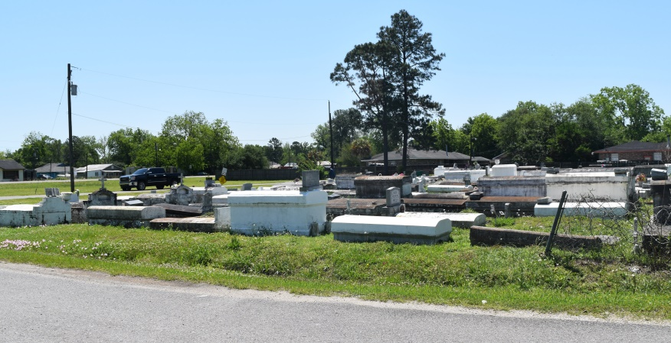

Albert Eli Johnson departed this life on Monday, September 15, 2003 at River Parishes Hospital, Laplace, LA. Son of the late Edgard and Sedonia Johnson. Husband of Joyce Richard Johnson. Father of Darryl and Altherio Robertson and Ashley Marie Johnson, five brothers: Edgar Jr., Slidell, LA. Phillip, Dwight Johnson of Laplace, LA. Carl, Calvin Johnson of Reserve, LA., four sisters: Stella Mae White, Sandra Hawkins of Reserve, LA. Grandfather of Alexx Damond Johnson, Altherio Francois, Darrielle and Tyrek Robertson. Godfather of Sylvia Jeffery Byers of Ramstein, Germany, Lisa Anderson, of Reserve, LA. and a host of nieces, nephews, uncles, aunts, sisters-in-laws, brothers-in-laws, other relatives and friends. A native and resident of Reserve, LA. Age 54.

Relatives and friends of the family, also pastors, officers and members of New Pilgrim Baptist Church and all neighboring churches are invited to attend Funeral services on Saturday, September 20, 2003 at 11:00 a.m. at the above name church, 107 Pilgrim Dr. Reserve, LA., Dr. Rev. Forell Bering, Sr. Pastor, officiating. Interment in Bethlehem Cemetery, Reserve, LA. Viewing will be on Friday from 5:30 P.M. until 7:00 P.M. at the funeral home, 134 Daisy St. and on Saturday 10:00 A.M. until service time at the church. Services entrusted to: Hobson Brown Funeral Home

Published by The Times-Picayune (New Orleans, Louisiana)

September 19, 2003