Charles Joseph

December 1, 1942 – June 25, 2002

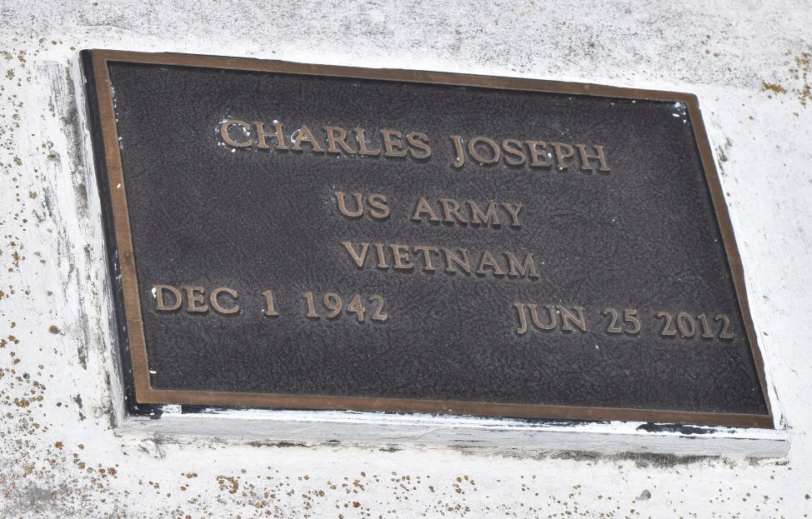

Charles Joseph died on Monday June 25, 2012, in Laplace, La., Husband of Joyce A. Joseph, Funeral Services on Friday June 29, 2012 for 11AM at Rising Star B.C., 620 Cardinal St. Laplace, La., Rev Donald August Pastor, Interment in Bethlehem Cemetery, Reserve, La., Visitation will begin at 10:00 am at church.  
  
Service Entrusted to Hobson Brown Funeral Home, 134 Daisy St., Garyville, La., 70051  
985-535-2516

**Times-Picayune, The (New Orleans, LA) - Friday, June 29, 2012**

**Contributed by Jane Edson**