Octavia Joseph

October 28, 1933 – May 28, 2011

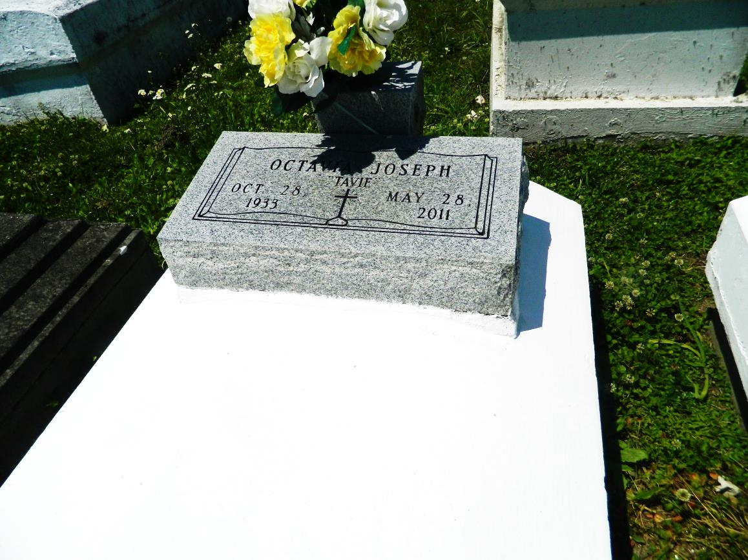

Octavia Joseph "Tavie" on Saturday, May 28, 2011 at Canon Hospice, Jefferson, LA. Daughter of the late Victoria Charles and Welman Joseph. Mother of Scheena Collins (Isaac, Jr.), Vanessa J. Winchester, Sgt. Wade Joseph (Dana) and the late Kim Joseph. Sister of Rev. Edward Joseph, Sr. (Gladys), Gistave, Wilbert (Marie), Herbert, (Ann) and Walter (Silvia Ann) Joseph, Rose Miller, Ethel Fisher, Earline Smallwood, the late Welman Joseph, Jr., Octave and Alvin Joseph. Sister-in-law of Ethel B. Joseph. Also survived by 6 grandchildren, 2 great grandchildren and a host of nieces, nephews, other relatives and friends. Age 77 years. A native of St James, LA and a resident of Reserve, LA.

Relatives and friends of the family, also pastors, officers and members of Bethlehem Baptist Church and all neighboring churches are invited to attend the funeral at Bethlehem Baptist Church, 147 East 20th Street, Reserve, LA, on Thursday, June 2, 2011 at 10:00 AM. Pastor Forell Bering, Officiating. Interment Bethlehem Cemetery, Reserve, LA. Visitation at the above named church from 8:00 am until service time.

SERVICED BY ROBOTTOM

**Downloaded from legacy.com 4/30/2018**