Robert Joseph

* August 5, 2018

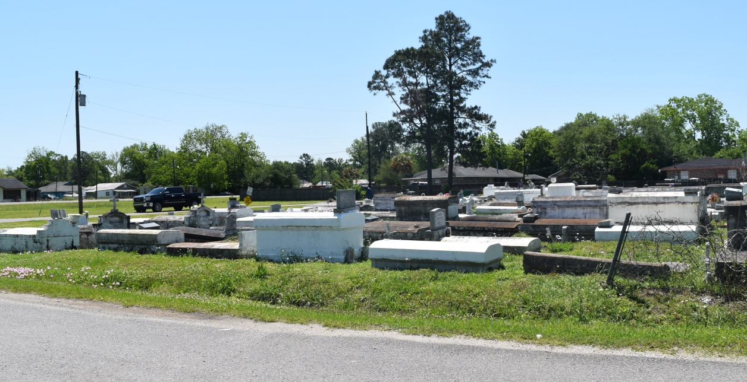

Robert Joseph, III, departed this life on August 5, 2018. Robert is survived by his family and friends. Celebration service will be held on Friday August 17, 2018 at Bethlehem B.C., 147 E. 20th St., Reserve, La 70084 at 10:00 am. Rev. Forell Bering officiating, Viewing will be at the above name church from 9:00 a.m. until Service Time. (ONLY). Internment in Church Cemetery. Professional Services entrusted to the caring staff Hobson Brown Funeral Home, 134 Daisy St. Garyville, La 70051. 985-535-2516

Published in TheNewOrleansAdvocate.com from Aug. 15 to Aug. 17, 2018