Henry LeBoyd Sr.

November 26, 1922 – October 5, 2012

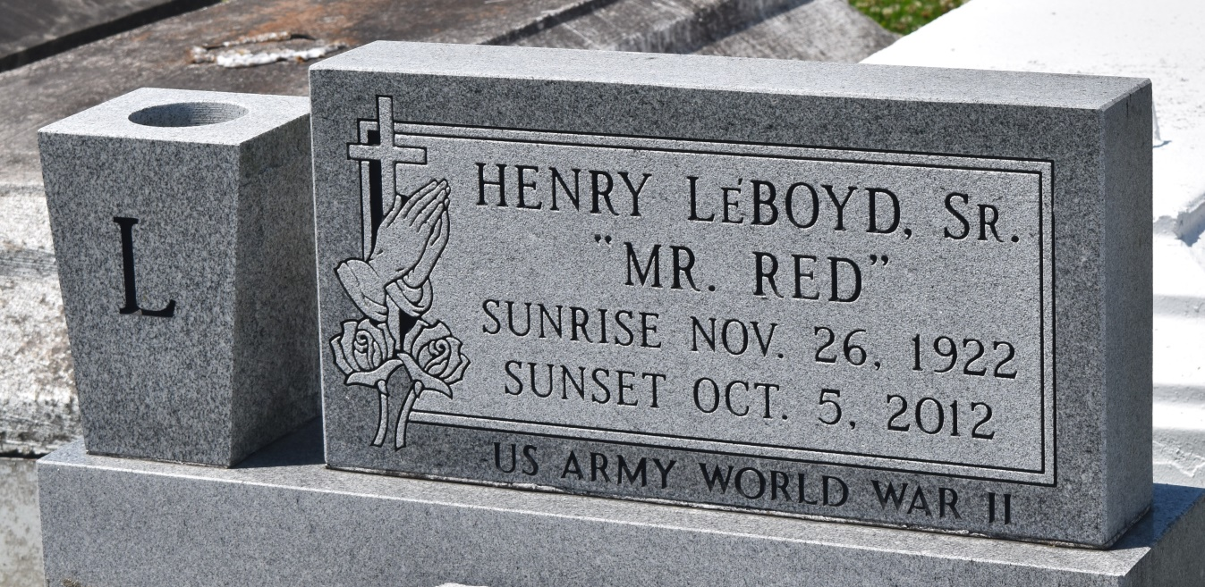

HENRY LEBOYD, SR. "MR. RED" on Friday, October 5, 2012 at Ochsner Hospital, Jefferson, LA. Son of the late Fannie Diggs and Paul LeBoyd. Beloved husband of the late Geraldine Johnson LeBoyd. Devoted father of Henry LeBoyd, Jr. (Glenda), Donald Ray LeBoyd (Betty), Hilton LeBoyd (Edna), Jacquelyn Reed (Jerry), Dianne LeBoyd, Karen Soule' (Terry), Barbara Taylor (Gordon) and Gail Cus (Roger) Brother of Freddie LeBoyd and Carol Jackson both of Baton Rouge, LA, the late Berlin Leboyd, Harrison Callahan, Grace Thomas and Ethel Johnson.  
  
Also survived by 12 grandchildren, 11 great grandchildren and a host of nieces, nephews, cousins, other relatives and friends. Age 89 years. A native and resident of New Sarpy, LA. A World War II Veteran, he was employed and retired from Universal Match Corporation after thirty years.  
  
Relatives and friends of the family, also pastors, officers and members of St. Matthews Baptist Church and all neighboring churches are invited to attend the funeral at St. Matthews Baptist Church, 604 E S Johnson Street, New Sarpy, LA on Saturday, October 13, 2012 at 11:00 AM Rev. Fred T. Porter, Pastor Officiating. Interment Bethlehem Cemetery, Reserve, LA. Visitation at the above named church from 9:00 AM until service.  
  
SERVICED BY ROBOTTOM

**Times-Picayune, The (New Orleans, LA) - Friday, October 12, 2012**

**Contributed by Jane Edson**