Van B. Lennix

Abt. 1939 – May 17, 2018

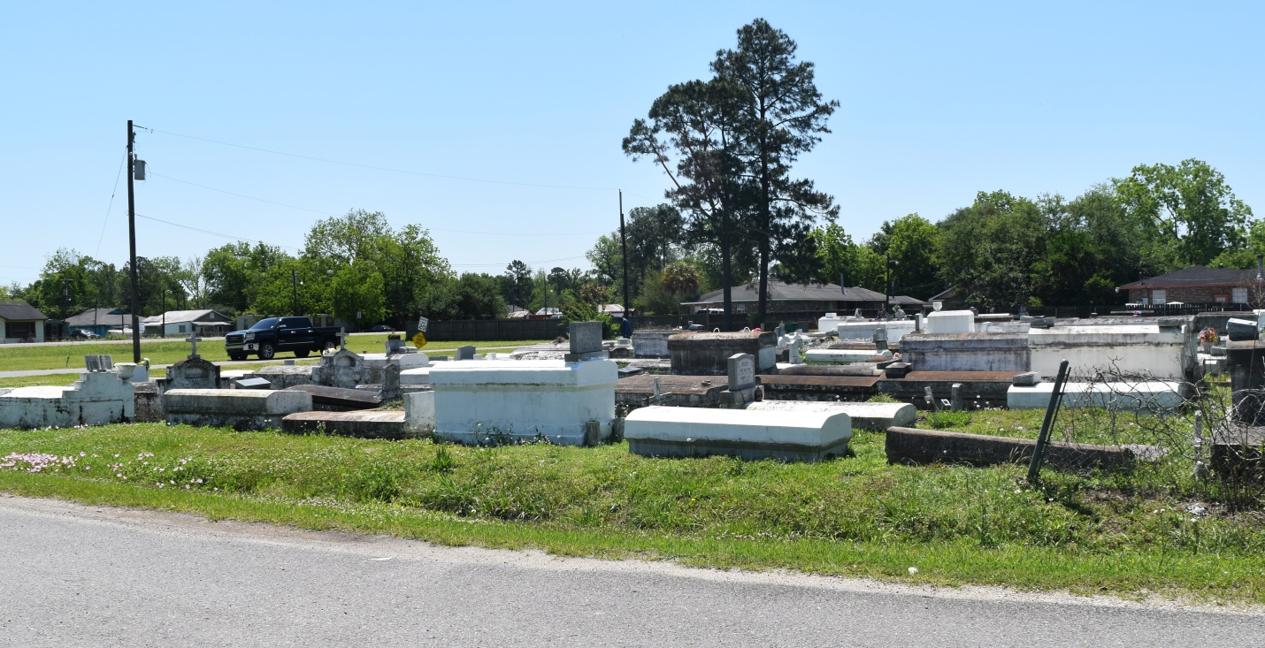

Van B. Lennix on Thursday, May 17, 2018 at East Jefferson General Hospital, Metairie, LA. Son of the late Evelina Carter and Isaac Lennix, III. Father of Opal Lennix, Paul Green (Theresa) and Tara Lennix. Brother of the late Nathaniel Lennix, Una Lennix Stephens, Lawrence (Rosalie Lennix - Living), Clarence Lennix and August Lennix. Also survived by 5 grandchildren, 1 great grandson, a devoted friend, Henry "Butch" Rose and a host of nieces, nephews, cousins, other relatives and friends. Age 79 years. A native and resident of LaPlace, LA. Relatives and friends of the family are invited to attend the funeral service at Robottom Mortuary, 850 Hwy 44 (River Road), Reserve, LA on Friday, May 25, 2018 at 10:00 AM. Interment Bethlehem Cemetery, Reserve, LA. Visitation at the above named funeral home from 9:00 AM until service time. SERVICED BY ROBOTTOM

Published in The Times-Picayune on May 23, 2018