Lorey Martin Jr.

June 22, 1940 – April 27, 2008

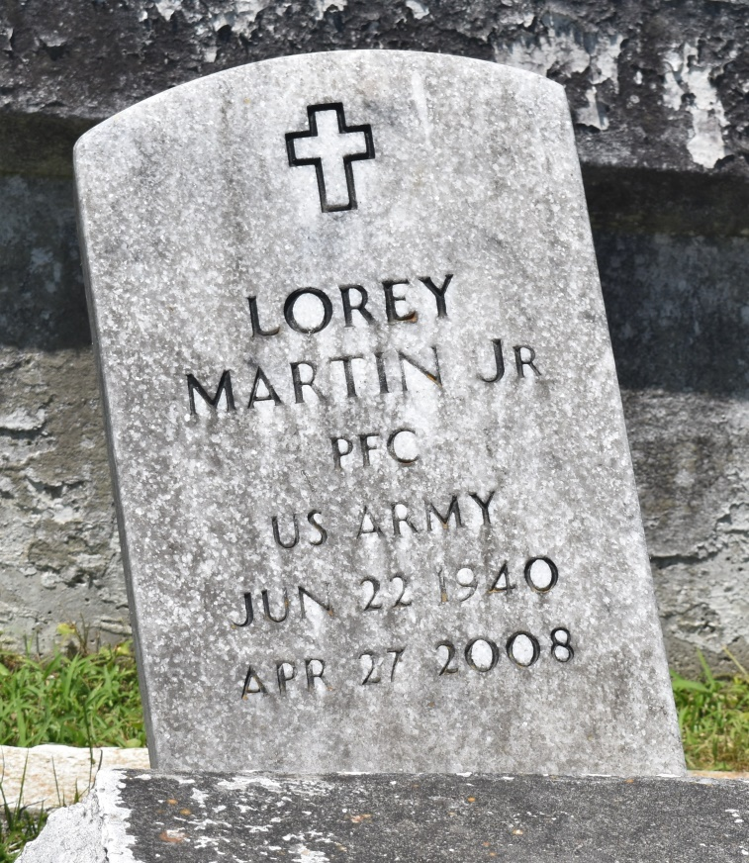

Lorey L. Martin, Jr., age 67, a Retired Supervisor for Tulane University, passed away on Sunday, April 27, 2008 in Laplace, La. Son of the late Dora Rebecca Taylor and Lorey Martin, Sr. Former husband by 1st marriage to Delores Deboue. Father of Robin M. Bailey, Dietrich Turcuit, Lorey Martin III, Anthony Martin, and the late Oneka Marie Martin. Brother of Mary Joy Manuel, Martha M. Keys, Larry Martin, Sr. Also survived by former wife, Sheryl Adams; 2 aunts, 2 uncles, 10 grandchildren, 1 great-grandchild son- and daughter-in-law, brothers- and sisters-in-law, a host of nieces, nephews, cousins, other relatives and friends. Mr. Lorey Martin served in the United States Army from 1958-1960 as a Marksman (Rifle). A native of New Orleans, La. and resident of Laplace, La.

Officers and members of Milesville Memorial Church of God in Christ and all neighboring churches are invited to attend the Funeral Service on Monday, May 5, 2008 at 11:00a.m. from the above named church, 129 Apple St., Laplace, La. Bishop Ronald Frank, Pastor, Officiating. Interment in Bethlehem Cemetery, Reserve, La, Viewing on Sunday at the church from 5:30-7:00 p.m. and on Monday at the church from 9:00a.m. until 11:00a.m. (ONLY)

Service entrusted to Hobson Brown Funeral Home, Garyville, La.

**Downloaded from legacy.com on 4/30/2018**