Bryant Joseph Perrilloux

September 24, 1982 – November 13, 2002

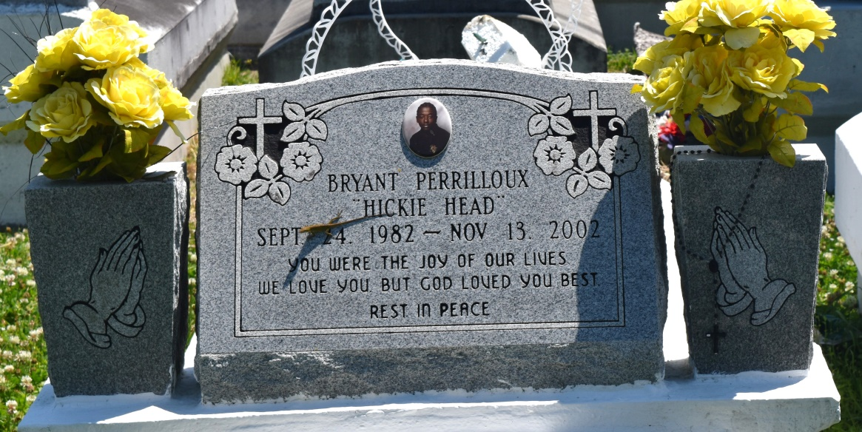

Bryant Joseph (Hicky Head) Perrilloux of Reserve, LA. on Wednesday November 13, 2002 at Ochsner Foundation Hospital. Son of Curtis Perrilloux, Sr. and Elva Cook Perrilloux. Step-son of Anita Perrilloux. Brother of Curtis Perrilloux, Jr. and Danielle M. Perrilloux. Step-brother of Lowery, Andre, Raynell, Roselyn Joseph, Chrisell Henry, Sharnel Reid and Reynette Lennex. Uncle of Anthony Young, Curtis Perrilloux, III and Jasmine Young. Grandson of Geraldine Perrilloux and the late Wilfred Perrilloux, Albert and Mattrie Cook. Brother-in-law of Naomi Perrilloux. Also survived by (9) aunts, (8) uncles, a host of cousins and friends. A native and resident of Reserve, LA. Age 20 years.

Relatives and friends of the family, also pastor, officers and members of the Bethlehem Missionary B.C., Our Lady of Grace Catholic Church. Employees of St. John Parish Council - Roads and Bridges, St. John Parish Clerk of Court, Dupre Transportation, Dupont, Sears and the 2002 Class of East St. John High School are invited to attend the funeral services on Wednesday November 20, 2002 at 11:00 A.M. from the Bethlehem Missionary B.C. East 20th St., Reserve, LA. Rev. Forell Bering Officiating. Interment Church Cemetery. Visitation at the Church after 9:00 A.M. THE BALONEY FUNERAL HOME in charge of arrangements.

**Downloaded from legacy.com 4/30/2018**