Cheryl Ann (Kenner) Perrilloux

September 1, 1961 – February 28, 2017

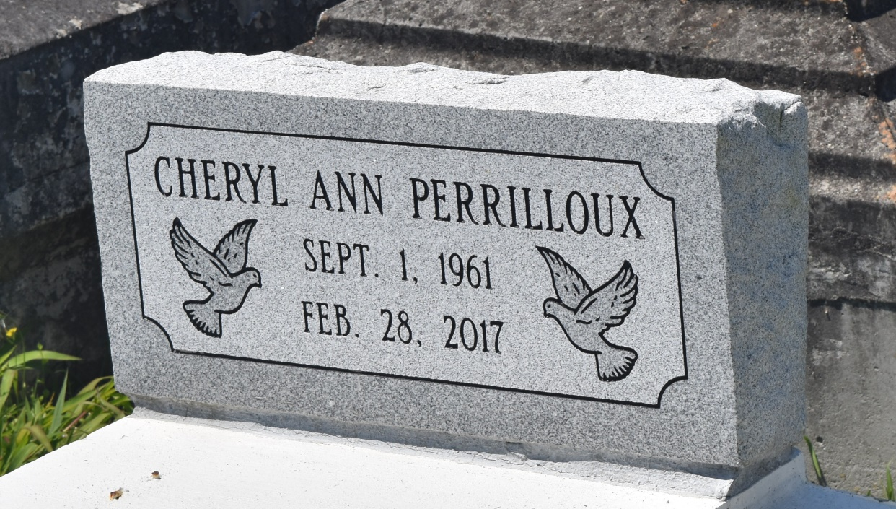

Cheryl Ann Kenner Perrilloux at the age of 55 yrs. departed this earthly life and entered into eternal rest on Tuesday February 28, 2017 at her residence in Reserve, La. Daughter of the late Pastor Calvin Kenner Sr. and Vivian Lane Kenner. Beloved wife of Adrian Perrilloux of Reserve, La. Loving mother of Eric, Keya, and Vivian Kenner. Sister of Mona K. Watkins (Warren), Calvin Kenner Jr. (Oritha), Beverly K. Robertson, Tinga, Shawn, Anthony Sr. (Terry), Joseph (Tristan), Stephen (Carlette), and Amos Kenner (Treaneice). Also survived by Thirteen Grandchildren, aunts, uncles, nieces, nephews others relatives and friends. She was a devoted member of Bethlehem Baptist Church where the Rev. Forell Bering is the Pastor. Cheryl was preceded in death by her parents Pastor Calvin Sr. and Vivian L. Kenner, In-laws Remy Jr. and Margaret Perrilloux, Remy III, Dale Perrilloux, Cheryl Frank and Robert Williams. She was a native of Norco, La and a resident of Reserve, La.

Pastors, Officers and Members of Bethlehem Baptist Church of Reserve, La., and all neighboring churches are invited to attend the home going celebration on Wednesday, March 8, 2017 at 11:00 am at Bethlehem Baptist Church, 147 East 20th St., Reserve, La. Pastor Forell Bering officiating. Interment in Church Cemetery. Visitation will be at the above name church from 10:00 am until service time.

Bardell's Mortuary of Mt. Airy, La. in charge. Information: 985-535-6837.

**Published in TheNewOrleansAdvocate.com from Mar. 6 to Mar. 9, 2017**