Dwna M. Perrilloux

February 29, 1964 – December 8, 2009

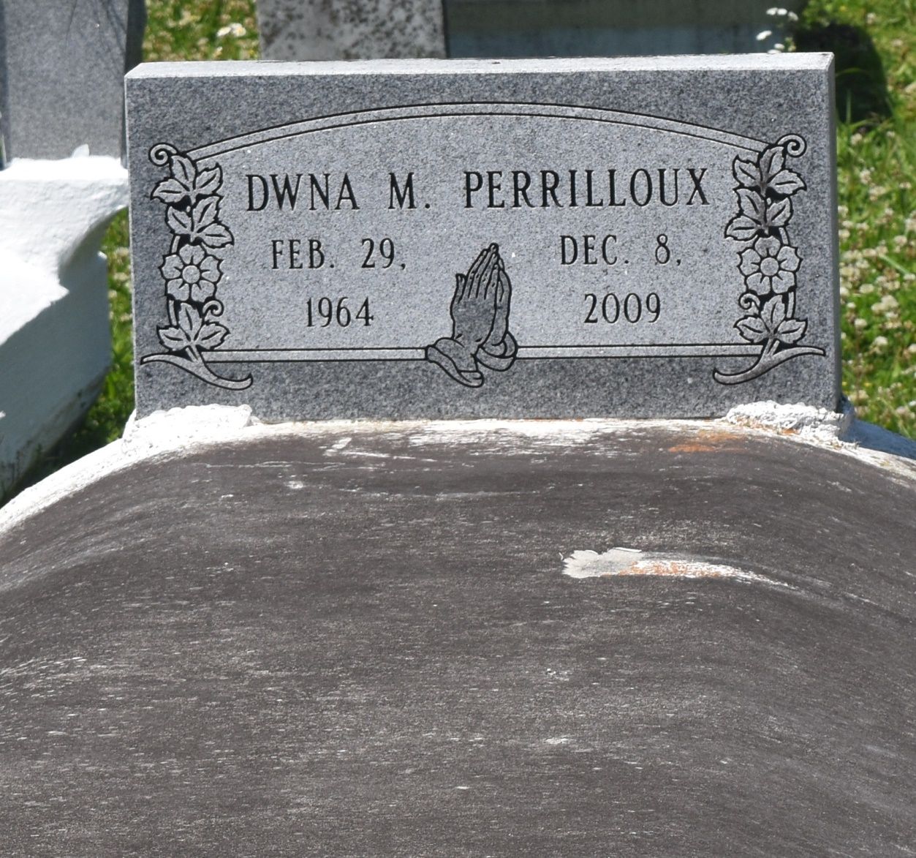

Dwna M. "Noonie" Perrilloux departed this life on Tuesday, December, 8, 2009, LaPlace, LA. Daughter of Geraldine S. Perrilloux and the late Wilferd Perrilloux. Mother of Ron D. Perrilloux. Sister of Wanda P. Calias, Judy P. Green, Curtis Sr, Marcelle Sr. Elmo Sr., and Keith Perrilloux. Grandmother of Rondell Perrilloux. Age 45. Also survived by and a host of nieces, nephews, other relatives and friends. A native and resident of Reserve, LA.  
  
Services will be on Tuesday, December 15, 2009 at 9:00 am at Bethlehem Baptist Church, 146 East 20th St., Reserve, LA. Rev. Forell Bering Pastor, officiating. Internment Private. Viewing at the church from 8:00 am until Service time.  
  
Service Entrusted to Hobson Brown Funeral Home, Garyville, La., 985-535-2516

**Times-Picayune, The (New Orleans, LA) - Monday, December 14, 2009**

**Contributed by Jane Edson**