Henry Sanders Jr

October 15, 1950 – April 16, 2011

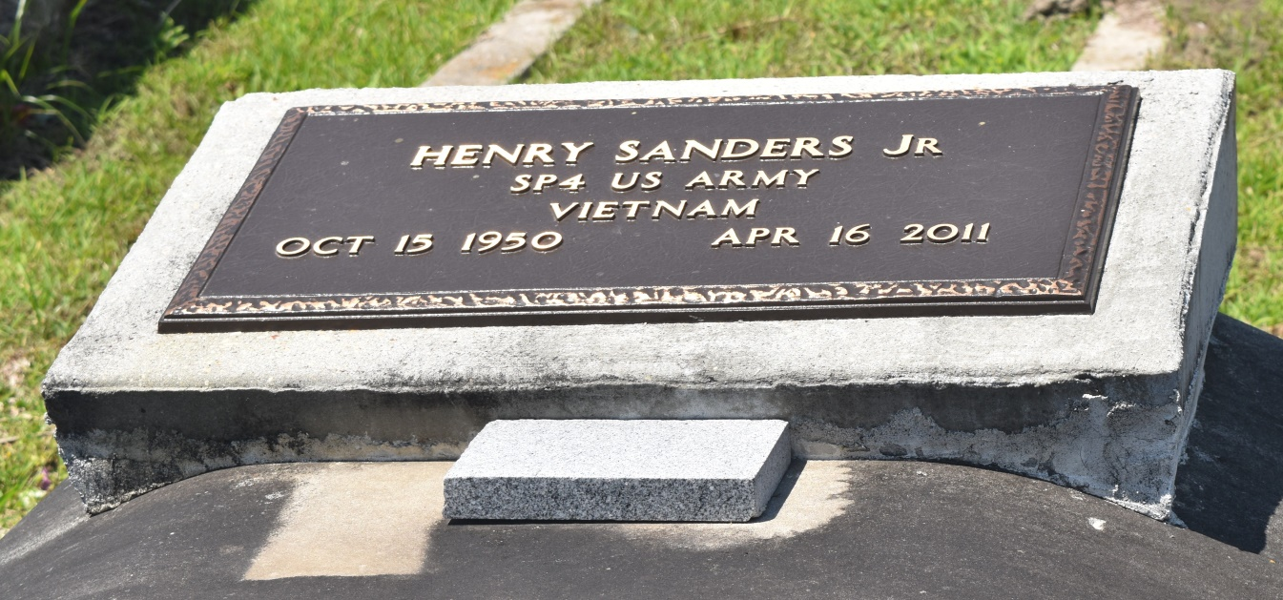

Henry Sanders, Jr. "Crab" "Buster" on Saturday, April 16, 2011 in New Orleans, LA. Son of Emma Frank Sanders and the late Henry Sanders, Sr. Husband of Lorriane James Sanders. Father of Brian Sanders and the late Torey Sanders. Brother of Earl Sanders, Madelyn S. Tyler (Henry), Geneiva S. Jones (Paul), Allen Sanders, Gerald Sanders (Vanessa), Lionel Sanders, Leonard Sanders, Sr. (Bernadine), Jackie S. Hargrove (Simon) and Debbie S. Craighead (Irvin). Also survived a host of nieces, nephews, other relatives and friends. Age 60 years. A native and resident of Reserve, LA.  
  
Relatives and friends of the family, also pastors, officers and members of Bethlehem Baptist Church and all neighboring churches are invited to attend the funeral at Bethlehem Baptist Church, 146 East 20th Street, Reserve, LA, on Friday, April 22, 2011 at 10:00 AM. Rev. Ferrell Bering, Pastor, Officiating. Interment: Bethlehem Cemetery, Reserve, LA. Visitation at the above named church from 9:00 AM until Service time.  
  
SERVICED BY ROBOTTOM

**Times-Picayune, The (New Orleans, LA) - Thursday, April 21, 2011**

**Contributed by Jane Edson**