Torrey Micheal Sanders

July 29, 1977 – March 9, 2008

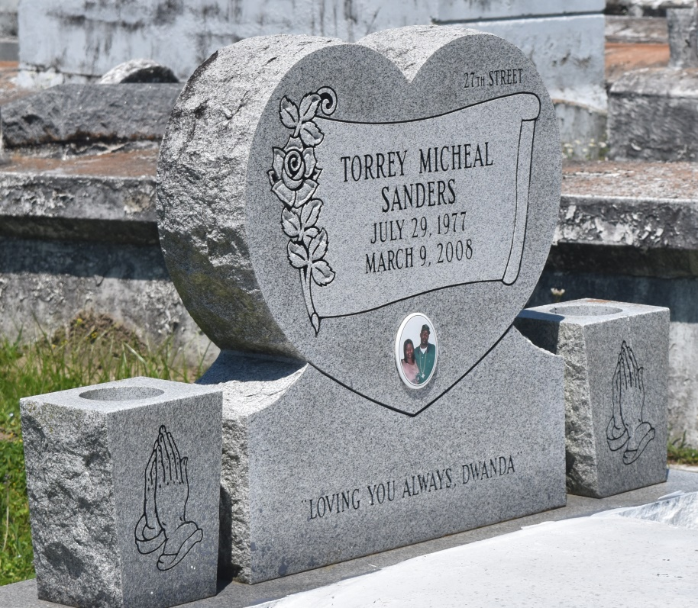

Torey Michael Sanders "Soup" on Sunday, March 9, 2008 in Reserve, LA. Son of Henry Sanders, Jr. and Angela Gabriel. Brother of Brian Anthony Sanders. Grandson of Lorraine Williams and Emma Sanders, the late Thomas Triche Williams and Henry Sanders, Sr. Devoted friend of Dwanda Perrilloux. Also survived by a host of aunts, uncles, cousin, other relatives and friends. Age 30 years. A native and resident of Reserve, LA.  
  
Relatives and friends of the family, also Pastors, officers and members of Tchopitoulas Chapel and all neighboring churches are invited to attend the Funeral Service at Tchopitoulas Chapel, Highway 44, Reserve, LA, on Friday, March 14, 2008 at 10:00 AM. Rev. Lionel Murphy, Sr. Officiating. Interment Bethlehem Cemetery, Reserve, LA. Visitation at the above named church Friday morning, March 14, 2008 from 9:00 AM until service time and Thursday, evening March 13, 2008 at ROBOTTOM MORTUARY, 850 Highway 44, Reserve, LA, from 4:00 PM until 6:00 PM.  
  
SERVICED BY ROBOTTOM

**Times-Picayune, The (New Orleans, LA) - Thursday, March 13, 2008**

**Contributed by Jane Edson**