Warren Nicholson

June 21, 1946 – September 19, 1999

Lester Adam Weston Sr.

December 7, 1918 – May 26, 2008

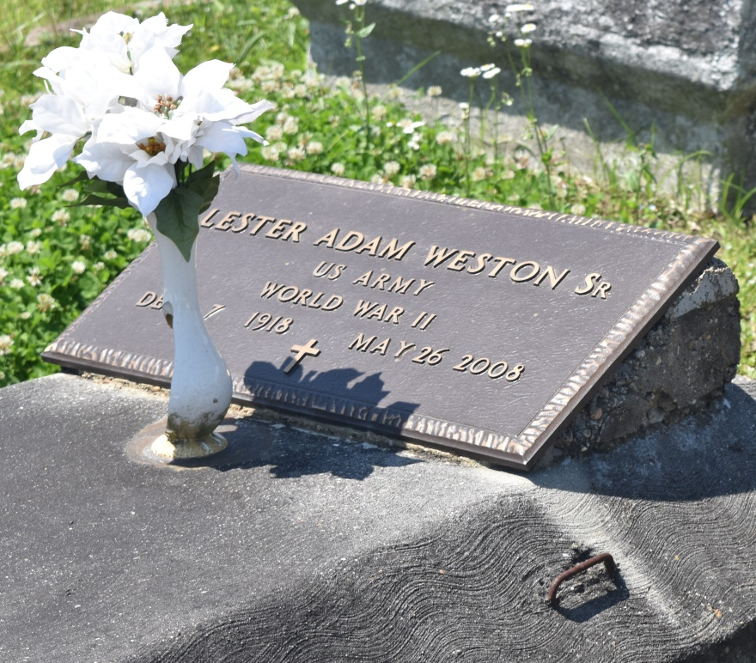

Lester Adam "Pops" Weston, Sr. entered into eternal rest on Monday, May 26, 2008 at 2:33 am at the age of 89. A native of Reserve, LA, resided in Kenner, LA for the past 60 years. Beloved husband of Helen Davis Weston. Son of the late Adam and Conelia Weston. Father of Lester (Pamela) Weston Jr. of LaPlace, LA, Darrel (Tiffany) Weston Sr. of Reserve, LA and Alfred Weston Sr. of New Orleans, LA. Survived by eight grandchildren; one great grandson; two brothers, Norma Weston of Reserve, LA and Edward Weston of Los Angles, CA; one aunt, Beatrice Anderson of New Orleans, LA and a host of nieces, nephews, other relatives and friends.  
  
Relatives and friends of the family, also Pastor, officers and members of Providence Baptist Church and all neighboring churches; Nehemiah Lodge # 72, Naomi Chapter 19 are invited to attend the Funeral Services from Providence Baptist Church, 11509 Jefferson Hwy., Kenner, LA, on Saturday, May 31, 2008 at 10:00 am. Viewing will begin at 9:00 am. Interment: Bethlehem Cemetery, Reserve, LA.  
  
Richardson Funeral Home of Jefferson is in charge of arrangements.

Times-Picayune, The (New Orleans, LA) - Friday, May 30, 2008

Contributed by Jane Edson