Dorothy (Bourgeois) Winzy

Abt 1928 – February 22, 2018

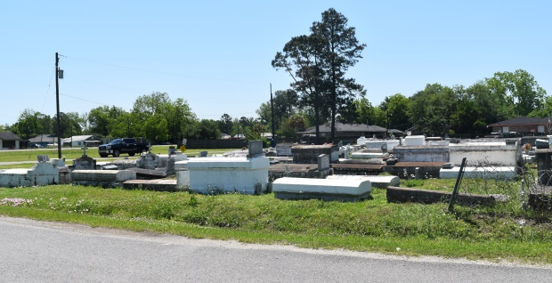

Dorothy Bourgeois "Dot-ty" Winzy at the age of 90 yrs. old departed this earthly life and entered into eternal rest on Thursday, February 22, 2018, at Canon Hospice in Jefferson, La. She will be forever remembered by her loving children: Clara W. Wilson, Helen W. Bryant (Bobby), Alfred Winzy (Geraldine), Clifford Daniels (Diane), Edward Campbell (Sheryl), and Carolyn Banks. She is also survived by 21 grandchildren, 42 great-grandchildren and 6 great-great-grandchildren, a devoted friend Liza Julien, and a faithful caregiver Barbara Eugene. Dorothy was preceded in death by her husband Frank Winzy, her father James Bourgeois, her mother Dorothy Denby, her brother George Bourgeois, her daughter Ida Lee Miller, her granddaughters Shantell and Vinetta Miller, and son-in-law Jesse L. Wilson. Also survived by a host of nieces, nephews, other relatives and friends. A native of Metairie (Shrewsbury) La. and a resident of LaPlace, La. Relatives and friends of the family, Pastors, Officers and Members of Bethlehem Missionary Baptist Church are invited to attend the Home-going Celebration on Saturday March 3, 2018, at 11:00am at Bethlehem Missionary Baptist Church, 147 East 20th Street in Reserve, La. Pastor Forell Bering Officiating. Interment in Bethlehem Cemetery. Visitation at the above named church from 9:00am until service time. Bardell's Mortuary of Mt. Airy, La., in charge. Information: 985-535-6837.

Published in TheNewOrleansAdvocate.com from Mar. 1 to Mar. 3, 2018