Arthur Fleming

October 12, 1930 – March 25, 2005

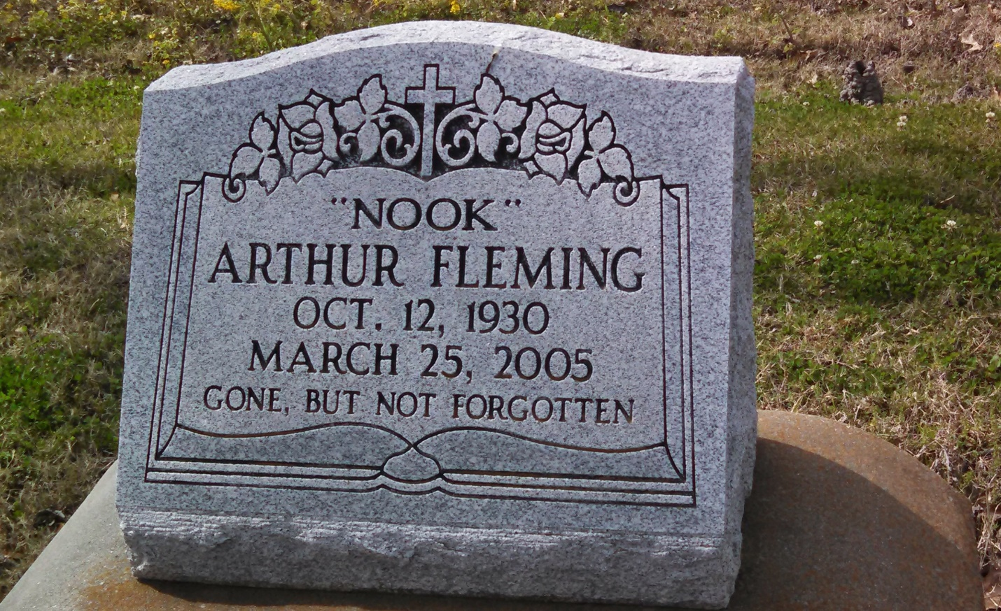

Photo by GeniHound

Arthur "Nook" Fleming died Friday of kidney failure at Twin Oaks Nursing Home. He was 75. Mr. Fleming was a lifelong resident of Garyville. Survivors include three brothers, Huey P. Fleming Sr., Ernest Fleming and Albert "Red Bill" Burl. A funeral will be held today at 11 a.m. at New Hopeful Baptist Church, 388 South Fig St., Garyville. Visitation will begin at 9:30 a.m. Burial will be in Marathon Bishop Cemetery. Hobson Brown Funeral Home is in charge of arrangements.

Times-Picayune, The (New Orleans, LA) - Wednesday, March 30, 2005

Contributed by Jane Edson