Cornelius Don Lee

Abt. 1973 - July 29, 2001

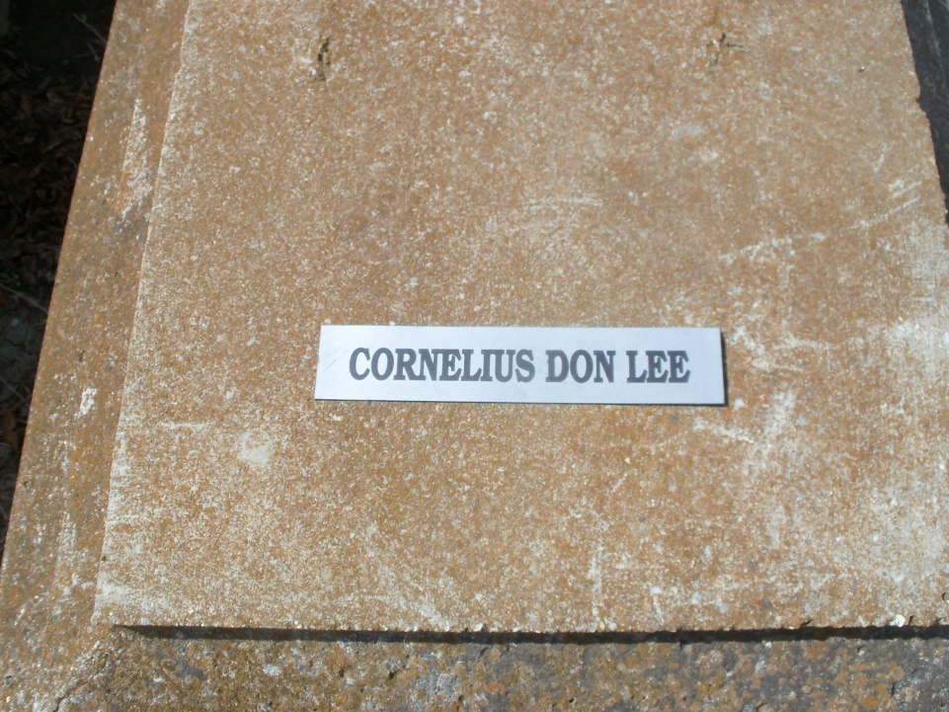

Photo by GeniHound

GARYVILLE - Cornelius Don Lee, 28, died July 29 in Houston, Texas. He was the father of Tyrone Starbert and Angel Starbert and the stepfather of Aaron Johnson. He was the son of Juanita Lee and Joe Camel Jr. and the brother of Darnell Lee and Dedric Camel. He was the grandson of the late Aldonia Lee. Services will be today at noon at St. Mark Baptist Church and interment will be in Marathon Cemetery in Garyville under the direction of Hobson Brown Funeral Home.

**L'Observateur, LaPlace, LA; August 04, 2001**