Roger Smith III

September 3, 1935 – September 6, 2004

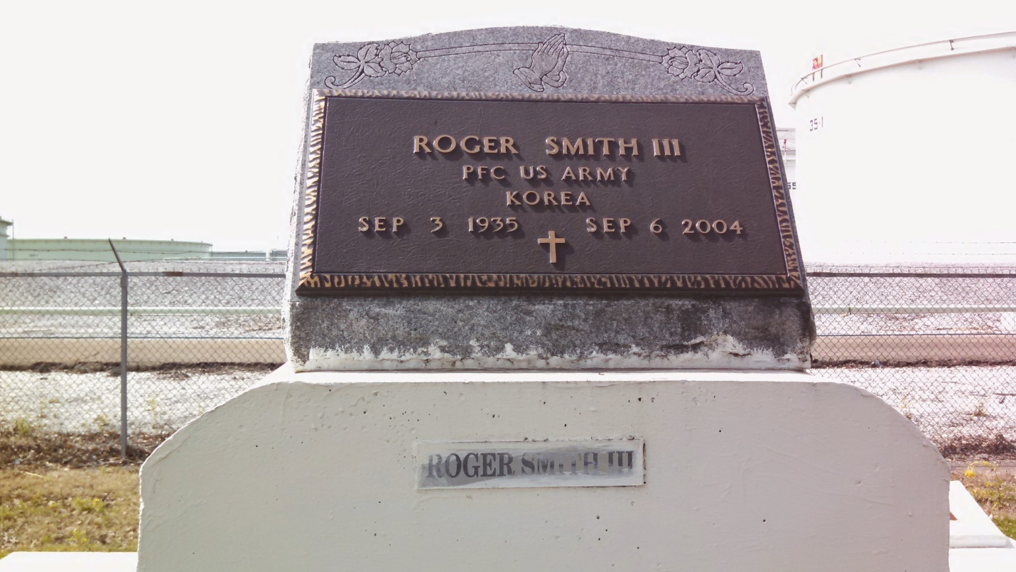

Photo by GeniHound

Roger "Montana" "Smitty" "Popee" Smith III, a retired mechanic for the transportation department of the St. John the Baptist Parish Sheriff's Office, died Monday of an aneurysm at West Jefferson Medical Center. He was 68. Mr. Smith was a lifelong resident of Garyville. He was an Army veteran. Survivors include his wife, Ester George Smith; a son, Roger Smith IV; seven daughters, Joyce and Laverne Gardner, Lois George, Jerlean Smith, Shander Wimberly, Ornell Harvell, and Deadrian Coneley; a brother, Clarence Smith Sr.; two sisters, Audrey Breaux and Lillie Mae Fobb; a stepbrother, Raymond Scott; two stepsisters, Geraldine Eugene and Patricia Watkins; 19 grandchildren; and 13 great-grandchildren. A funeral will be held Monday at 11 a.m. at New Hopeful Missionary Baptist Church, 388 S. Fig St., Garyville. Visitation will be today from 5:30 to 7:30 p.m. at Hobson Brown Funeral Home, 134 Daisy St., Garyville, and Monday beginning at 9 a.m. at the church. Burial will be in Marathon Bishop Cemetery in Garyville.

Times-Picayune, The (New Orleans, LA) - Sunday, September 12, 2004

Contributed by Jane Edson