Leona (Anderson) Wishom

March 27, 1933 – February 18, 2005

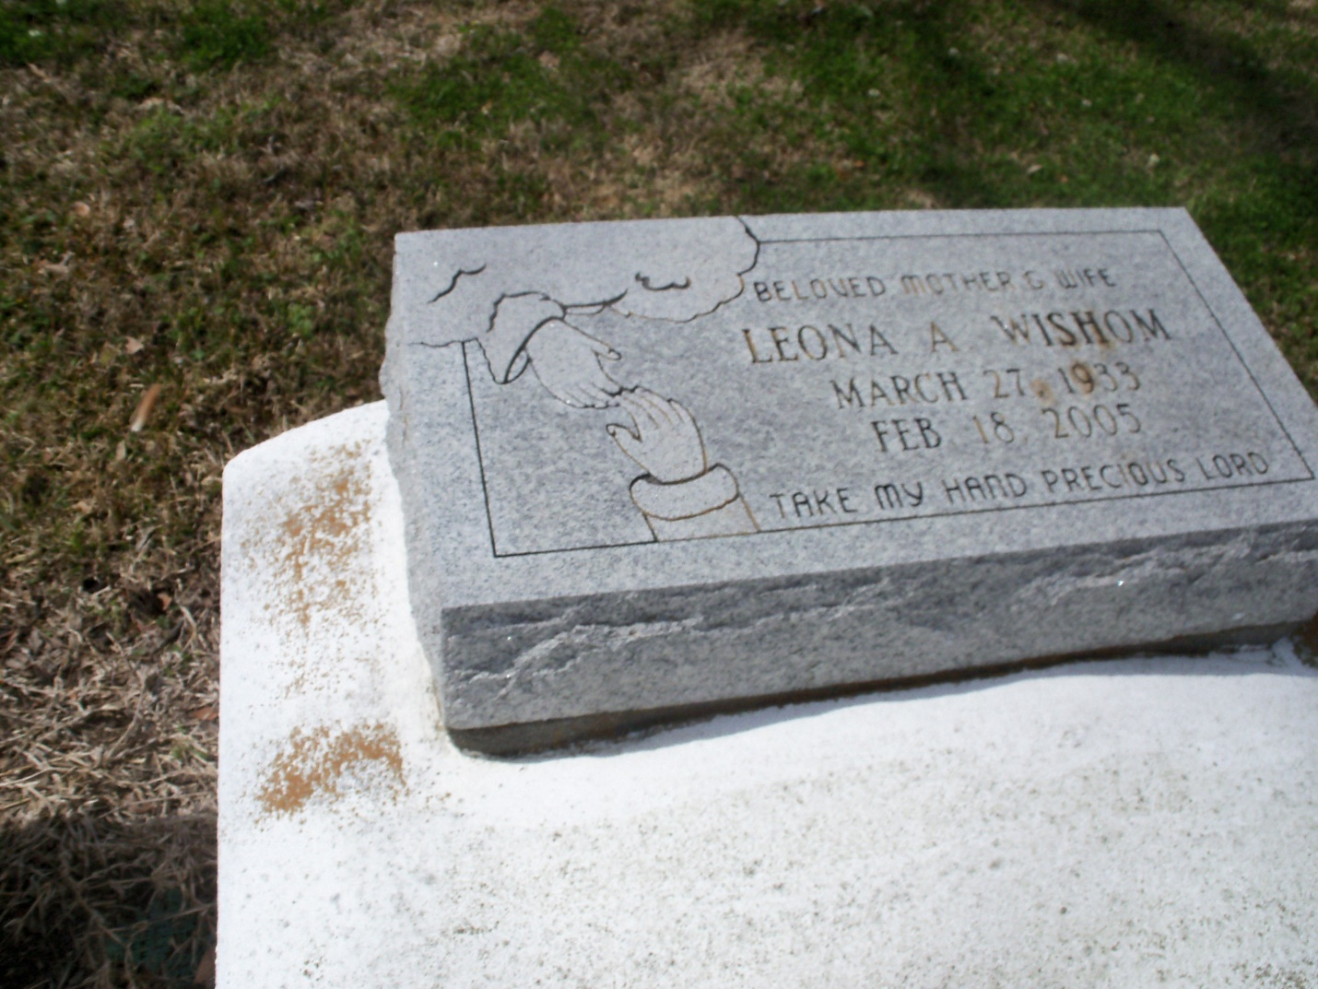

Photo by GeniHound

GARYVILLE - Leona A. Wishom, 71, a native and resident of Garyville, died Feb. 18. She was the wife of Johnny Wishom Sr., and mother of Jajaun Swafford, Johnny Jr., Jacqueline and Jeryl Wishom. She was also the daughter of the late John and Elizabeth K. Anderson, and sister of Gladys Placide, and the late Edna Jackson, Isiah Talfair, Arthur, Clarence and Robert Anderson. She is also survived by six grandchildren and six great-grandchildren. Services are today at 11 a.m., at Mt. Zion No. 1 Baptist Church, Garyville, with interment at Marathon Cemetery, Garyville.

L'Observateur (La Place, LA) - Wednesday, February 23, 2005

Contributed by Jane Edson