Gustavia Mary (Edwards) Bailey

September 14, 1940 – November 5, 2012

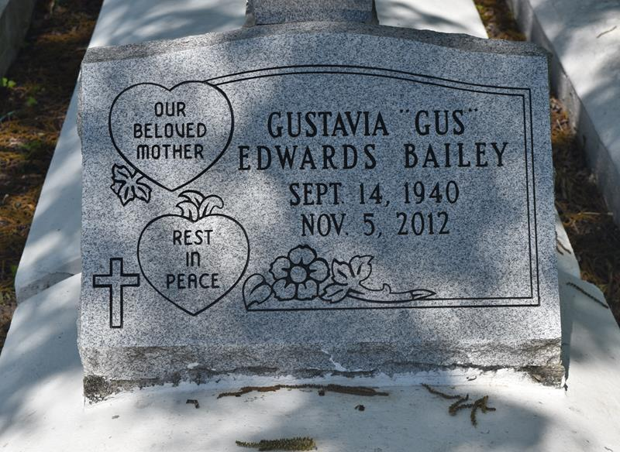

Gustavia Mary Edwards Bailey "Gus" on Monday, November 5, 2012 at River Region Hospice, River Ridge, LA. Daughter of the late Ferdinand Edwards, Sr. and Elsie Rousselle Edwards. Devoted mother of Todd Edwards, Sean and Kim Bailey. Sister of Margaret Morris, Ernestine Tuckerson, Cheryl Louper, Constance Grows, Elsie Jones, Tyrone, Clarence, Allen and Murry Edwards, the late Ferdinand Edwards, Jr., Earline Allen and Florence Brimmer. Grandmother of A'Yauna Jack, A'Najna, A'Layzha, Tar-Talaysha, Mya and Tamia Bailey. Also survived by her devoted friends, Judy Barre of New Orleans, LA, Florence Burke of Edgard, LA, Janice Matthews of Lutcher, LA and a host of nieces, nephews, aunts, uncles, other relatives and friends. Age 72 years. A native and resident of Edgard, LA.

Relatives and friends of the family, also pastors, officers and members of New Jerusalem and The Historic Bethlehem Baptist Churches, priest and parishioners of St. John the Baptist Catholic Church and all neighboring churches and employees of USDA - FGIS, TCCI, Staff of St. Charles Parish Hospital Emergency Department, and the Faculties, Staffs and student bodies of West St. John High and Elementary Schools are invited to attend the funeral at New Jerusalem Baptist Church, 152 East Sixth Street, Edgard, LA on Saturday, November 10, 2012 at 11:00 AM. Rev. K. Maurice Tillman, Pastor, Officiating. Interment New Jerusalem Cemetery, Edgard, LA. Visitation at the above named church from 9:00 AM until service time. SERVICED BY ROBOTTOM

The Times-Picayune (New Orleans, LA) Nov. 8 to Nov. 9, 2012