Jah’Man Michael Bailey

September 14, 1983 – April 5, 2009

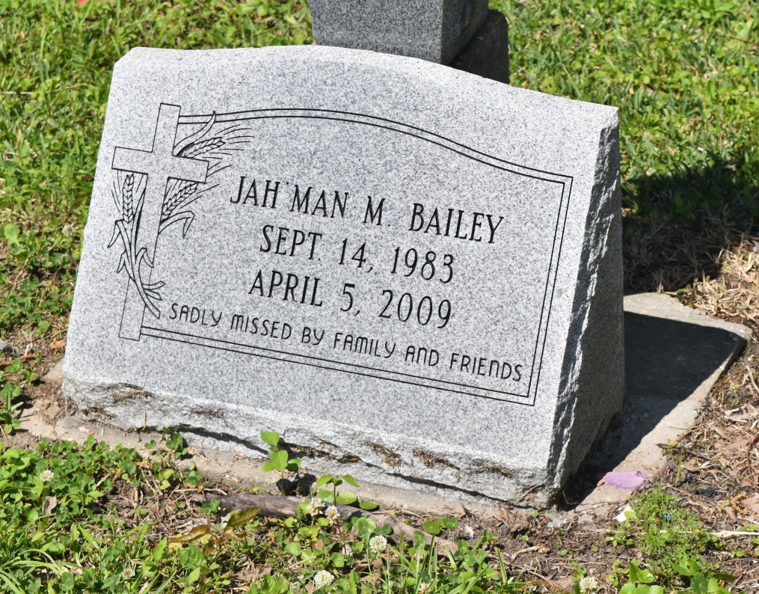

JAHMAN MICHAEL BAILEY on Sunday, April 5, 2009 at St Charles Hospital, Luling, LA.  
  
Son of Medgra Bailey and Tyrania Thomas, Sr. Father of Rashod Major, Jahman Bailey, Jr., A'Mahni Bailey, Jakera Simmons-Honor, and Ty'Jah Bailey. Brother of Irian Bailey. Step - father of Tamia, Tamaya, and Tyrania Thomas, Jr. Grandson of Virtreater Bailey. Also survived by a host on aunts, uncles, cousins, other relatives and friends. Age 25 years. A native of Edgard, LA and a resident of Boutte, LA.  
  
Relatives and friends of the family, also pastors, officers and members of Philadelphia Baptist Church and all neighboring churches are invited to attend the funeral service at Philadelphia Baptist Church, 217 Smith Street, Hahnville, LA on Tuesday, April 14, 2009. Rev Joseph Johnson, Pastor, Officiating. Interment New Jerusalem Cemetery, Edgard, LA. Visitation at the above named church from 8:00 AM until service time.  
  
SERVICED BY ROBOTTOM

Times-Picayune, The (New Orleans, LA) - Monday, April 13, 2009

Contributed by Jane Edson