Rose Mary (Washington) Bolden

June 23, 1914 – August 13, 2001

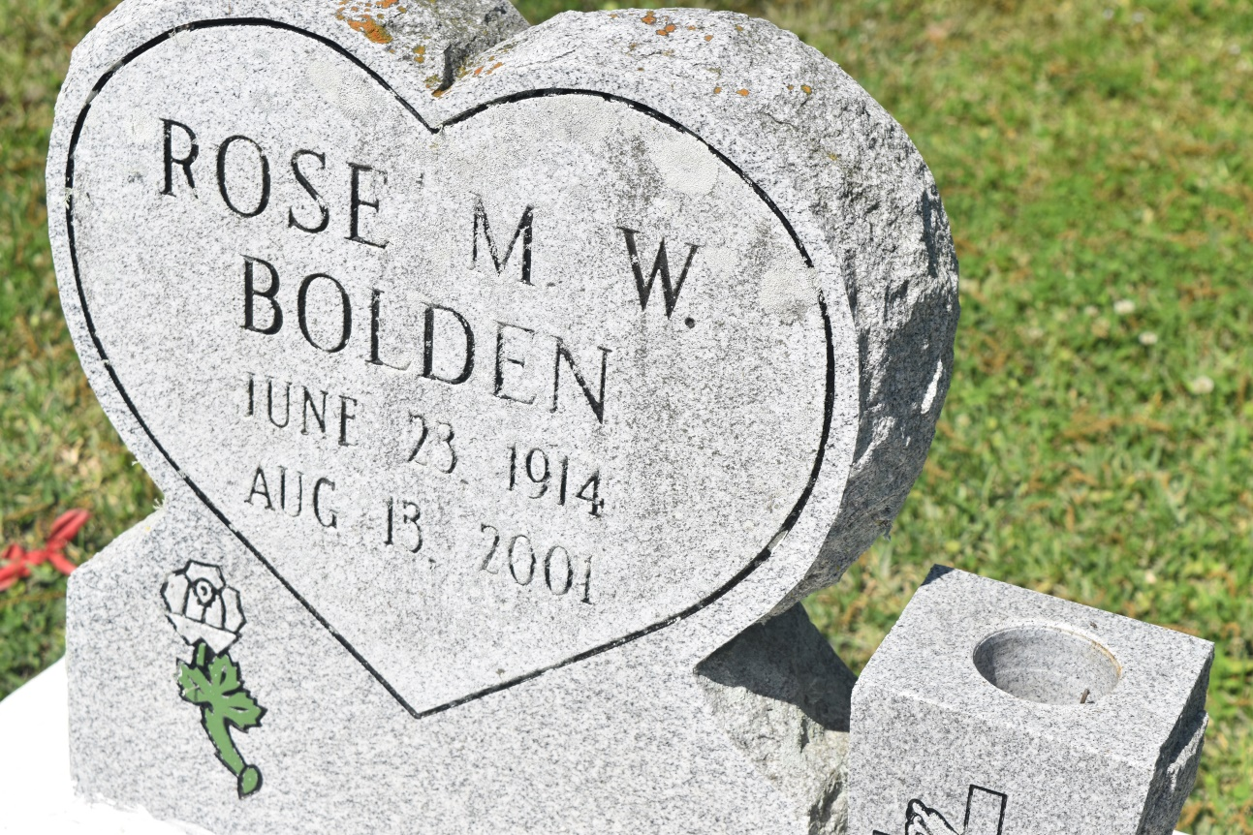

Rose Mary Washington Bolden, a homemaker, died Friday of carbon monoxide poisoning at her home in Reserve. She was 51. Mrs. Bolden was a lifelong resident of Reserve. Survivors include her husband, Percy Bolden Jr.; a son, Allen Holland Jr.; a daughter, Sarah Holland; five brothers, Edward Craighead, and Harold, Allen, Larry and Jeffery Washington; two sisters, Glendora Warren and Brenda Lumar; and two grandchildren.

A funeral will be held Wednesday at 11 a.m. at True Light Baptist Church in Garyville. Visitation will begin at 10 a.m. Burial will be in Zion Travelers Cemetery. Hobson Brown Funeral Home is in charge of arrangements.

Times-Picayune, The (New Orleans, LA) - Tuesday, June 26, 2001

Contributed by Jane Edson