Cynthia Marie (Johnson) Borne

January 6, 1951 – May 12, 2007

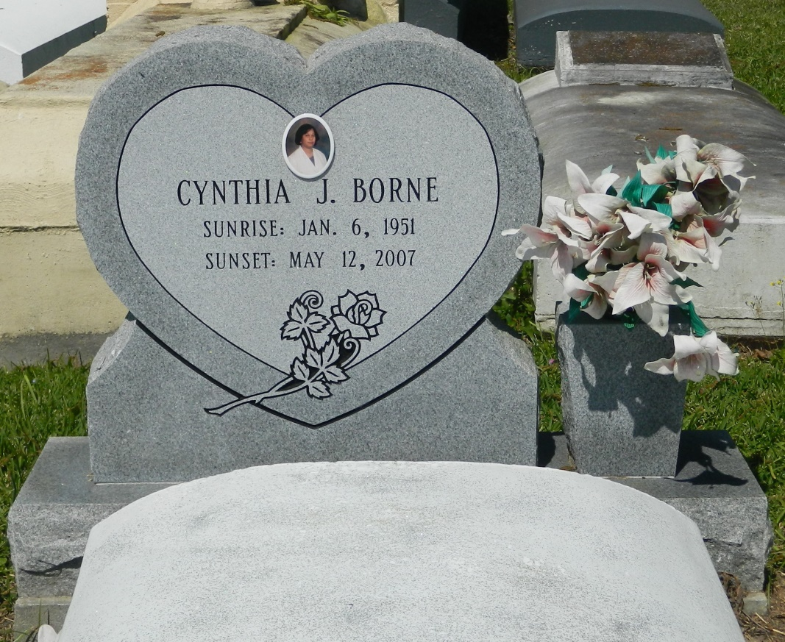

Cynthia Marie Johnson Borne of Edgard, LA. at Canon Hospice on Saturday, May 12, 2007. Beloved daughter of Elouise Johnson and the late Rev. F. J. Johnson of Edgard. Beloved wife of Roy Michael Borne. Mother of Alicia Mona' and Melanie Ann Borne. Step-mother of Tristan (Lisa) Borne. Grandmother of Phillip I. Pickney, Jr. Step grandmother of Jordan and Javan Borne. Granddaughter of Julia Young of Reserve, LA. Sister of Pastor Rose and (Pastor Michael) Grant of Winnsboro, Mary (Ivy) Armant, Dianne (Steve) Terry, Rev. D. Joseph (Dianne) Johnson, Jr., Raymond (Gloria), Anthony, Leonard, and the late Abraham Johnson (Claudia) of Edgard, LA. Daughter-in-law of the late Norman and Olga Borne. Godchild of Morris Alexander. Also survived by a host of aunts, uncles, nieces, nephews, sisters and brother-in-law, other relatives and friends. A native and resident of Edgard, LA. Age 56 years.

Relatives and friends of the family, also Pastor, officers and members of the New Jerusalem B.C., Morning Star B.C. Wallace, LA., Philadelphia B.C.-Hahnville, Greater New St. Peter B.C., 2nd African B.C., St. John The Baptist Catholic Church and neighboring churches. Employees of St. John the Baptist Parish Library, Entergy, Stone & Webster, Vision Center of the South, 2nd Ward High Class of '70' Faculty and staff of Texas Chiropractic College, are invited to attend the funeral services on Saturday, May 19, 2007 at 11:00 a.m. from the Jerusalem Baptist Church, 126 East 6th St., Edgard, LA. Rev. Dr. Joseph Johnson, Jr., officiating. Interment church cemetery. Visitation at the church after 8:00 a.m. on Saturday.  
 The Baloney Funeral Home, L.L.C., 399 Earl Baloney Dr., Garyville, LA 70051, 985-535-2540 In Charge of Arrangements

Times-Picayune, The (New Orleans, LA) - Friday, May 18, 2007

Contributed by Jane Edson